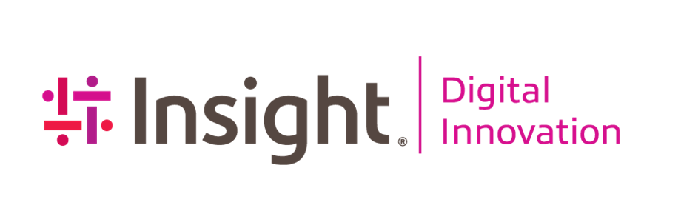



**Data Platform Documentation**

**Prepared for Sundt on 2023-10-20**

Contents

Overview 5

Knowledge Transfer Sessions and Other Documentation Artifacts 5

Data Platform Overview 5

Resource and Technology Descriptions 7

Azure DevOps 7

Terraform 7

Azure Active Directory 8

Subscription 8

Resource Group 8

Key Vault 9

Azure SQL Database 10

Data Factory 11

Data Lake 14

Databricks 15

Power BI 15

Metadata 15

How to Connect to the Metadata Database 16

Email Notifications 17

Data Ingestion 19

Infrastructure 19

Orchestration and Metadata 20

Monitoring 23

Azure Data Factory Monitoring 23

Monitoring Self-Hosted Integration Runtime 24

Azure Data Factory Log Views 27

Tuning and Performance 28

Self-Hosted Integration Runtime 28

ADF Batch Size 28

Governance 29

Data Processing 29

Infrastructure 29

Orchestration and Metadata 30

Azure Data Factory 30

Creating Dimension and Fact Tables 34

Databricks Functions and Classes 35

User-Defined Functions 35

Python Classes 36

Web App Pipelines 36

Monitoring 39

Azure Data Factory Monitoring 39

Azure Data Factory Log Views 40

Tuning and Performance 40

Databricks Clusters 40

ADF Batch Size 43

Delta Table Performance Tuning 44

Governance 45

The Unity Catalog object model 46

Metastores 46

Managed storage 47

Storage credentials and external locations 48

Catalogs 49

Schemas 50

Tables 50

Managed tables 50

External tables 50

Access to Tables and Views 51

Views 53

Dynamic Views 53

Applying RLS to Silver Tables 54

Models 56

Identity management for Unity Catalog 56

Admin roles for Unity Catalog 57

Data permissions in Unity Catalog 57

Databricks Access 57

Table Access 61

Serving and Consumption 62

Infrastructure 62

Orchestration and Metadata 63

Databricks SQL Warehouse 63

Power BI 64

Monitoring 65

Tuning and Performance 66

Source Control and Environment Promotion 67

General Branching Strategy 67

Azure DataFactory 69

Source Control 70

ADF Publish 71

Environment Promotion 72

Databricks 76

Source Control 76

Environment Promotion 76

Azure SQL Database (Metadata Database) 81

Source Control 81

Environment Promotion 81

# Overview

## Knowledge Transfer Sessions and Other Documentation Artifacts

The contents of this document contain documentation related to data platform for Sundt. Other detailed information, including Power BI, is not covered in this document. That documentation lives in the areas located below.

* Recorded Knowledge Transfer: All recorded knowledge transfer sessions and other sessions can be found in Sharepoint located at [Sundt Data Warehouse 2023 -> Insight Knowledge Transfer -> Recordings](https://sundtconstruction.sharepoint.com/:f:/r/teams/SundtDataWarehouse2023/Shared%20Documents/Data%20Warehouse/Insight%20Knowledge%20Transfer/Recordings?csf=1&web=1&e=5F6w7G)
* Visio Diagram: Visio diagrams found in this document can be located at [Sundt Data Warehouse 2023 -> Insight Documentation](https://sundtconstruction.sharepoint.com/:f:/r/teams/SundtDataWarehouse2023/Shared%20Documents/Data%20Warehouse/Insight%20Documentation?csf=1&web=1&e=g4zf9z)
* Power BI Documentation: Power BI documentation for certified datasets can be found at [Sundt Data Warehouse 2023](https://healthpointchcwa.sharepoint.com/teams/data-services-team/Shared%20Documents/Forms/AllItems.aspx?ga=1&viewid=f414c9ce%2Dfa59%2D4add%2Db1a8%2Dcfda9e120f4f) -> [Power BI Certified Datasets Documentation](https://sundtconstruction.sharepoint.com/:w:/r/teams/SundtDataWarehouse2023/Shared%20Documents/Data%20Warehouse/Power%20BI%20Certified%20Datasets%20Documentation.docx?d=w533acecf2ffd4ca9b63646bdde60b80f&csf=1&web=1&e=bkBnP7)
* Dimensional Models: Applicable dimensional models (visio diagram) for defined subject area be found in Sharepoint located at [Sundt Data Warehouse 2023 -> Insight Documentation -> Dimensional Model](https://sundtconstruction.sharepoint.com/:u:/r/teams/SundtDataWarehouse2023/Shared%20Documents/Data%20Warehouse/Insight%20Documentation/Dimensional%20Models.vsdx?d=wf5fc73334bd64070a55be30f4af4ef33&csf=1&web=1&e=pdqkYE)

## Data Platform Overview

This documentation will cover the Data Platform hosted in Azure. The architecture diagram below highlights the different components that the data platform is comprised of:

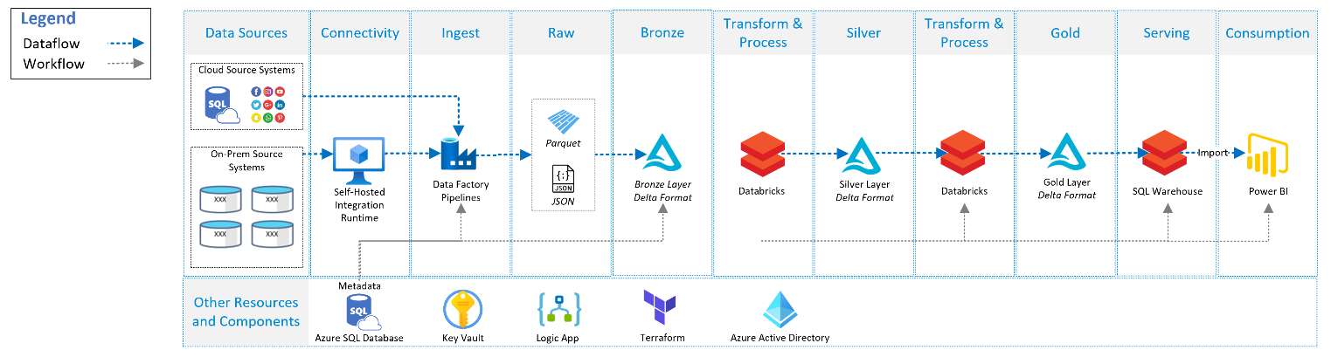

Figure 1 -data platform architecture diagram showing the metadata driven ETL process and components across the different environments.

You can also take the architecture diagram above and organize it into different modules to show the data platform broken out into different functional areas. The diagram below shows the different modules, or functional areas, of the data platform:

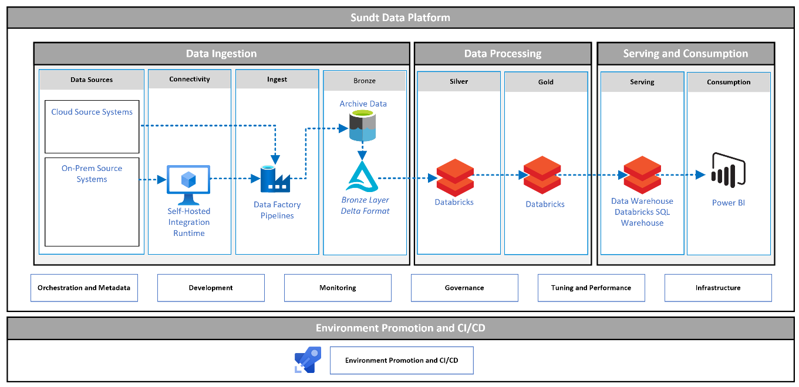

Figure 2 -data platform Modules

The different functional area in Figure 2 can be further described below:

**Data Ingestion:** This is where you connect to different types of data sources, whether they are cloud or on-premises data sources and in the format of structured (SQL tables) or semi-structured (JSON, csv files). The data ingestion area is designed to be flexible and scalable to connect and ingest data of all shapes and sizes to bring them into the core data lake in Azure for storage and analysis. This data is organized in the data lake in a folder structures and file format for organization, scalability, and analytics on source data.

**Data Processing:** Once data is ingested, it needs to be cleansed, transformed and processed into a reporting friendly format. This is the data processing functional area. This is where majority of development work takes place in effort to clean bad data and create a star schema with dimension and fact tables based off of business requirements.

**Serving and Consumptions:** Data is served and consumed by end users. End users could be business users or end users could be analysts (e.g. BI analysts). Databricks SQL Endpoints act as the data warehouse for ad-hoc query and analysis, and is formally known as a [lakehouse](https://www.databricks.com/blog/2020/01/30/what-is-a-data-lakehouse.html) (a data warehouse built on a data lake). Power BI serves as the semantic layer for analytics that is representation of data that makes it easier for any user to access, visualize, and analyze data.

**Environment Promotion and CI/CD:** Once your code has been written, it needs to be stored in source control for versioning and promoting to other environments. It also need to be designed in a way that allows multiple developers to work collaboratively on different elements to add features or resolve bugs, all while ensuring they are working off of the same code base and data. This process is referred to as continuous integrations and continuous deployment, or CI/CD. Continuous integration is a step in which all code is merged as developers complete code in order to run automated builds and tests. Continuous deployment is the process of moving software that has been built and tested successfully into production.

## Resource and Technology Descriptions

### Azure DevOps

[Azure DevOps](https://learn.microsoft.com/en-us/azure/devops/user-guide/services?view=azure-devops#repos) supports a collaborative culture and set of processes that bring together developers, project managers, and contributors to develop software. It allows organizations to create and improve products at a faster pace than they can with traditional software development approaches.

In the case of the data platform, it used to store source and version control using repos to allow developers to collaborate on code and track changes made to the code base. Source control is an essential tool for multi-developer projects. It is also used for [pipeline](https://learn.microsoft.com/en-us/azure/devops/pipelines/get-started/what-is-azure-pipelines?view=azure-devops) and release management to deploy to higher environments (e.g. UAT and production).

### Terraform

[Terraform](https://www.terraform.io/) is an open-source infrastructure as code software tool that enables you to safely and predictably create, change, and improve infrastructure. This was used at the beginning of the project to deploy all of the infrastructure and networking components in the data platform Subscription.

The terraform source code can be found in Azure DevOps in the following repositories:

* [DW2023-IaC](https://dev.azure.com/sundt/DataWarehouse2023/_git/DW2023-IaC)

Terraform was used to deploy all of the Azure resources and networking in the core subscription platform subscription at the beginning of the data platform project, along with assigning some management policies. This document will not cover Terraform artifacts as Terraform was used simply to deploy the data platform, it is not intended to manage infrastructure ongoing for the data platform**. It is not recommended to run the IaC pipeline to rebuild infrastructure as some settings have been changed in the Azure portal (as opposed to in Iac) and will result in these key settings being removed and/or resources being destroyed. Terraform was used simply to deploy the data platform, it is not intended to manage infrastructure ongoing for the data platform**

### Azure Active Directory

[Azure Active Directory (Azure AD)](https://learn.microsoft.com/en-us/azure/active-directory/fundamentals/active-directory-whatis) is a cloud-based identity and access management service. Azure AD enables your employees access external resources, such as Microsoft 365, the Azure portal, and thousands of other SaaS applications. Azure Active Directory also helps them access internal resources like apps on your corporate intranet, and any cloud apps developed for your own organization.

### Subscription

An Azure subscription is a logical container used to provision resources in Azure. It holds the details of all your resources like virtual machines (VMs), databases, and more. When you create an Azure resource like a VM, you identify the subscription it belongs to. A subscription is generally used as a unit of management, billing, and scale.

**Dev/Test Subscription Name:** IT-DataWarehouse-DevTest

**Production Subscription Name:** IT-DataWarehouse-Prod

### Resource Group

A [resource group](https://learn.microsoft.com/en-us/azure/azure-resource-manager/management/manage-resource-groups-portal) is a container that holds related resources for an Azure solution. The resource group can include all the resources for the solution, or only those resources that you want to manage as a group. You decide how you want to allocate resources to resource groups based on what makes the most sense for your organization. Generally, add resources that share the same lifecycle to the same resource group so you can easily deploy, update, and delete them as a group.

|  |  |
| --- | --- |
| **Azure Resource Group Names** | |
| **Environment** | **Resource Name** |
| Development | rg-dw2023-westus-dev  rg-dw2023-westus3-dev |
| Test | rg-dw2023-westus-test  rg-dw2023-westus3-test |
| Production | rg-dw2023-westus-prod  rg-dw2023-westus3-prod |

### Key Vault

[Azure Key Vault](https://learn.microsoft.com/en-us/azure/key-vault/general/overview) is used to securely store and tightly control access to tokens, passwords, certificates, API keys, and other secrets. You can only view secrets in the key vault when you are on the Sundt network (e.g. virtual workspace).

**Note:** There is currently no environment promotion process for Key Vault secrets. This means that if you add new secrets in the development environment, you must MANUALLY create these new secrets in other environments as well (e.g. Test and production).

It is also important to note that unless otherwise noted in the secret name, Key Vault secrets that contain connection strings (metadata connection string) or access tokens (e.g. Databricks access token) for other Azure resources, contain the connection string or access token for that respective environment. This means that the secret ***sec-azure-sql-server-pwd*** in the development environment contains the password for the admin user in the metadata database in the dev environment. In the UAT Key Vault, this same secret name the password for the admin user in the metadata database in the UAT environment.

#### Access Policies

In order to access the Key Vault and the Key Vault secrets, not only does a user have to have permissions on the resources using Access Control (IAM), but the user also must have an ***Access Policy***. A Key Vault access policy determines whether a given security principal, namely a user, application or user group, can perform different operations on Key Vault secrets, keys, and certificates. You can assign access policies using the Azure portal, the Azure CLI, or Azure PowerShell. You can learn how to create an [***Access Policy*** here](https://learn.microsoft.com/en-us/azure/key-vault/general/assign-access-policy?tabs=azure-portal).

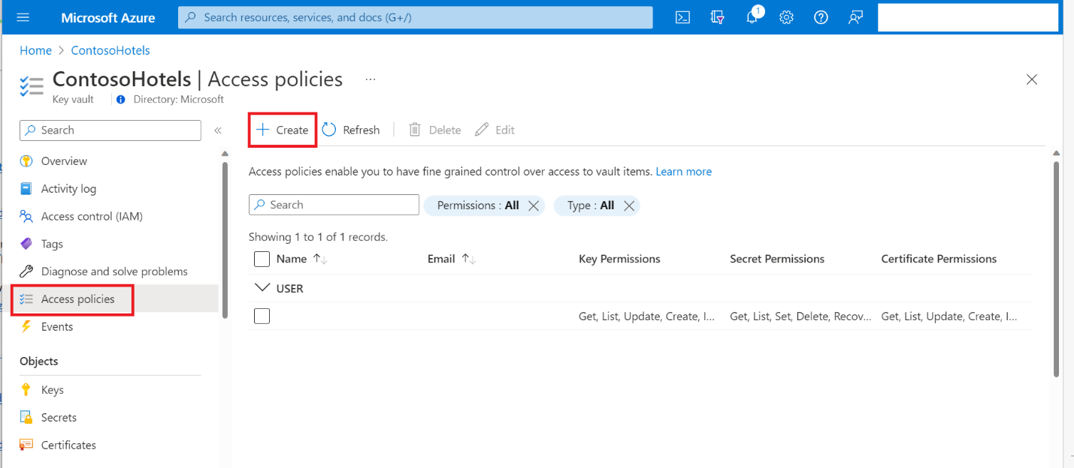

Figure 3 Shows where you can see and create access policies when viewing a Key Vault

|  |  |
| --- | --- |
| **Azure Key Vault Resource Names** | |
| **Environment** | **Resource Name** |
| Development | kv-dw2023-westus3-dev |
| Test | kv-dw2023-westus3-test |
| Production | kv-dw2023-westus3-prod |

### Azure SQL Database

[Azure SQL Database](https://learn.microsoft.com/en-us/azure/azure-sql/database/sql-database-paas-overview?view=azuresql) is a fully managed platform as a service (PaaS) database engine that handles most of the database management functions such as upgrading, patching, backups, and monitoring without user involvement. Azure SQL Database is always running on the latest stable version of the SQL Server database engine and patched OS with 99.99% availability. PaaS capabilities built into Azure SQL Database enable you to focus on the domain-specific database administration and optimization activities that are critical for your business.

|  |  |
| --- | --- |
| **Azure SQL Server Resource Names** | |
| **Environment** | **Resource Name** |
| Development | sql-metadata-dw2023-dev-sdt |
| Test | sql-metadata-dw2023-test-sdt |
| Production | sql-metadata-dw2023-prod-sdt |

#### Configure the Azure SQL Database Size

The Azure SQL database’s in the data platform only contain metadata and logging information from Azure Data Factory. The databases are configured with very small settings that can always be adjusted:

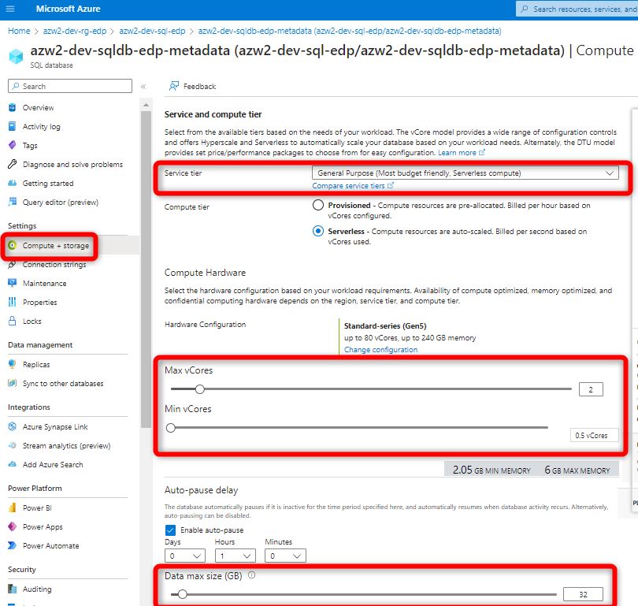

#### Connecting to the Azure SQL Database

You can find connection string information, along with usernames and passwords for the metadata database in the Key Vault using the secrets below:

* **Connection String:** sec-metadata-db-connection-string
* **Admin username**: sec-azure-sql-admin -username
* **Admin Password:** sec-azure-sql-admin -pwd

### Data Factory

[Azure Data Factory](https://learn.microsoft.com/en-us/azure/data-factory/introduction) is a cloud-based data integration service that allows you to create data-driven workflows in the cloud for orchestrating and automating data movement and data transformation. ADF does not store any data itself. It allows you to create data-driven workflows to orchestrate the movement of data between supported data stores and then process the data using compute services in other regions or in an on-premise environment. It also allows you to monitor and manage workflows using both programmatic and UI mechanisms.

|  |  |
| --- | --- |
| **Azure Data Factory Resource Names** | |
| **Environment** | **Resource Name** |
| Development | adf-dw2023-dev-sdt |
| UAT | adf-dw2023-test-sdt |
| Production | adf-dw2023-prod-sdt |

#### EDP Naming Convention

**Pipelines:**

* prefixed with ***pl***
* camelCase
* Naming convention for ingestion pipelines: ***pl<description><data source type> <Full or incremental>*** 
  + ***Example:*** plSourceToBronzeSqlFull
* Naming convention for other pipelines ***pl<description>***
  + ***Example:*** plRawToBronze

**Datasets:**

* Prefixed with ***ds***
* camelCase
* Naming convention ***ds<data source type><description if applicable>***
  + Example: ***dsRedShift*** or ***dsAdlsCsv***

**Linked Services:**

* Prefixed with ***ls***
* camelCase
* Naming convention ***ls<data source type><data source authentication type if applicable> <description if applicable>***
  + Example: ***lsSqlManagedIdentity***

**Triggers:**

* Prefixed with environment name (e.g. DEV, UAT, PROD) and ***tr***
  + ***Example:*** DEV_tr
  + Prefixed with environment name so your CICD process automatically turns triggers on/off per environment based on environment prefixes and target environment during release.
* camelCase
* Naming convention: ***tr<description if applicable><Frequency>***
  + **Example:** DEV_trSalesforceWeekly

**Parameters and Variables:**

* camelCase

#### Integration Runtime

The [Integration Runtime (IR)](https://learn.microsoft.com/en-us/azure/data-factory/concepts-integration-runtime) is the compute infrastructure used by Azure Data Factory and Azure Synapse pipelines to provide the following data integration capabilities across different network environments.

* **Self Hosted Integration Runtime:** A self-hosted IR is used for running copy activity between a cloud data stores and a data store in private network.

If you want to perform data integration securely in a private network environment that doesn't have a direct line-of-sight from the public cloud environment, you can install a self-hosted IR in your on-premises environment behind a firewall, or inside a virtual private network. The self-hosted integration runtime only makes outbound HTTP-based connections to the internet.

The development and test ADF share the same self-hosted integration runtime. The production ADF uses it’s own integration runtime.

|  |  |
| --- | --- |
| **Environment** | **Name and IP Address** |
| Dev/Test Integration Runtime | TEMADFDEV02 10.10.12.30 |
| Prod Integration Runtime | TEMADFPRD02 10.10.12.31 |

### Data Lake

Azure Data Lake is a cloud platform designed to support big data analytics. It provides unlimited storage for structured, semi-structured or unstructured data. It can be used to store any type of data of any size.

Data Lake Storage Gen2 builds on Blob storage and enhances performance, management, and security in the following ways:

* **Performance** is optimized because you don't need to copy or transform data as a prerequisite for analysis. Compared to the flat namespace on Blob storage, the [hierarchical namespace](https://learn.microsoft.com/en-us/azure/storage/blobs/data-lake-storage-namespace) greatly improves the performance of directory management operations, which improves overall job performance.
* **Management** is easier because you can organize and manipulate files through directories and subdirectories.
* **Security** is enforceable because you can define POSIX permissions on directories or individual files.

Also, Data Lake Storage Gen2 is very cost effective because it's built on top of the low-cost Azure Blob Storage. The extra features further lower the total cost of ownership for running big data analytics on Azure.

Because Databricks is placed in the *westus* region, the data lake was also placed in that region.

|  |  |
| --- | --- |
| **Azure Storage Account Resource Names** | |
| **Environment** | **Resource Name** |
| Development | sadlsdw2023devsdt |
| Test | sadlsdw2023testsdt |
| Production | sadlsdw2023prodsdt |

#### Delta Lake/Delta Tables

[Delta Lake](https://learn.microsoft.com/en-us/azure/databricks/delta/) is an open-source framework and technology built on top on a datalake. It is an optimized storage layer that provides the foundation for storing data and tables in Databricks. It extends files stored on a datalake with a file-based transaction log for ACID transaction and scalable metadata handling.

Tables in thedata platform are stored on the data lake in delta table format. The approach to build tables on the datalake is called a [data lakehouse](https://www.databricks.com/glossary/data-lakehouse#:~:text=A%20data%20lakehouse%20is%20a,(ML)%20on%20all%20data.). A data lakehouse is a new, open data management architecture that combines the flexibility, cost-efficiency, and scale of data lakes with the data management and ACID transactions of data warehouses, enabling business intelligence (BI) and machine learning (ML) on all data.

### Databricks

The [Databricks](https://docs.databricks.com/introduction/index.html) Lakehouse Platform provides a unified set of tools for building, deploying, sharing, and maintaining enterprise-grade data solutions at scale. Databricks integrates with cloud storage and security in your cloud account, and manages and deploys cloud infrastructure on your behalf. Databricks is used to process, store, clean, and share datasets for BI. Databricks is the core resource for transforming and serving data to users and Power BI.

At the time of writing, Databricks serverless SQL Warehouse was only support in the West US region. Therefore, Databricks and the datalake was provisioned in this region.

|  |  |
| --- | --- |
| **Azure Databricks Resource Names** | |
| **Environment** | **Resource Name** |
| Development | dbw-dw2023-dev-sdt |
| Test | dbw-dw2023-test-sdt |
| Production | dbw-dw2023-prod-sdt |

### Power BI

Power BI is a unified, scalable platform for self-service and enterprise business intelligence (BI). Connect to and visualize any data, and seamlessly infuse the visuals into the apps you use every day. Power BI is used to distribute applications (apps) containing different reports to different groups across the organization. Currently, Sundt is using [Power BI Premium Capacity](https://learn.microsoft.com/en-us/power-bi/enterprise/service-premium-what-is) and has the P1 SKU. This means that app or report consumers do not require a license, licenses are only required for individuals that create datasets and reports intended to be shared.

This document will not cover Power BI.

# Metadata

All orchestration is driven by metadata stored in the Azure SQL database. This metadata is used to dynamically populate orchestration activities in ADF across the entire data platform environment. The image below illustrates the metadata schema and the function of each table, stored procedure, and view:

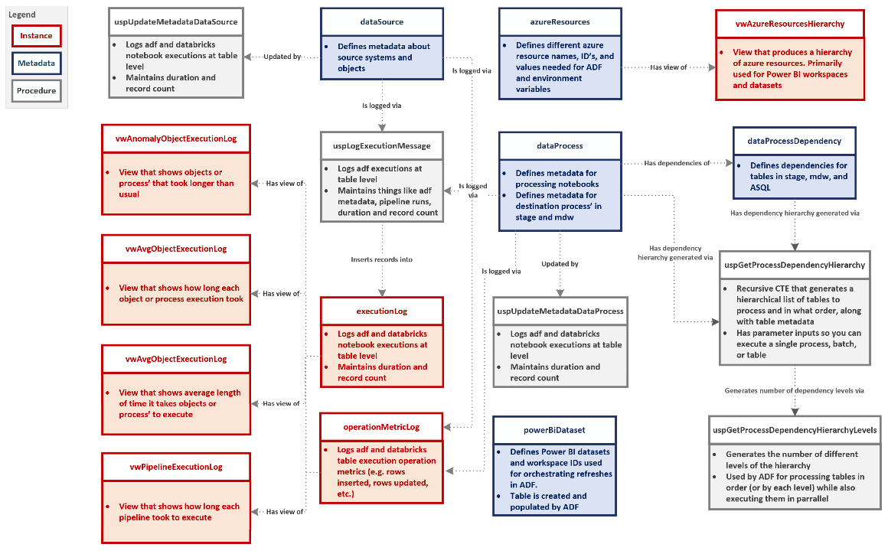

Figure 4 Metadata schema in the Azure SQL Database.

Metadata tables are updated and maintained by data engineers. Below are some key things to note about different process’ and metadata:

* In order to ingest data, you need metadata records in ***adf.dataSource***.
* In order to process tables into stage you need metadata records in ***adf.dataProcess***
* In order to process tables or notebooks in the silver and gold layer, you need metadata records in ***adf.dataProcess*** and ***adf.dataProcessDependency***.
* In order to refresh Power BI datasets from Azure Data Factory (ADF), you need metadata in ***adf.powerBiDatasets***.
  + This table gets populated from the ADF pipeline called *plUpdateDatasetId*. Right now this table only contains certified datasets used form the web application.

### How to Connect to the Metadata Database

Connect Using the SQL Admin Credentials  
You can connect to the Azure SQL Database using SSMS by specifying the database server, as shown in the image below. You can also use *SQL Authentication* using the SQL admin credentials.

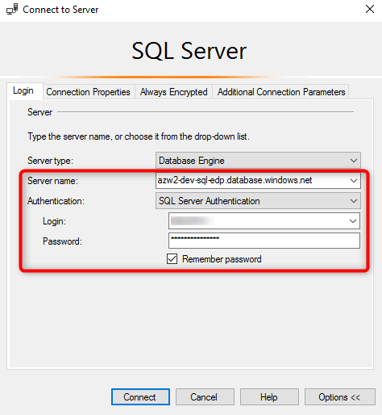

You can get the SQL admin credentials for each server in their respective key vault (you must be on the BI server or Virtual workspace to access the key vault) under the secrets called ***sec-azure-sql-admin-pwd***and ***sec-azure-sql-admin-user***

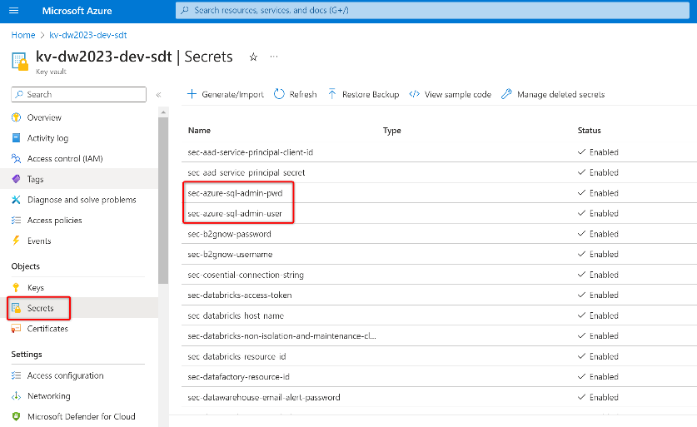

# Email Notifications

During the ETL process, Azure Data Factory will send out email success/failure notifications. Currently, these emails are sent from [Notifcations@Sundt.com](mailto:Notifcations@Sundt.com). Credentials for this account are stored in the key vault. These email notifications are sent out from the logic app in the environments respective resource group. This logic app is triggered by an HTTP request from the Azure Data Factory pipeline *plLogMsgAndSendEmail.*

The figure below show where the error handling pipeline lives in ADF, along with it’s parameters and the workflow that triggers the Logic App to send email notifications:

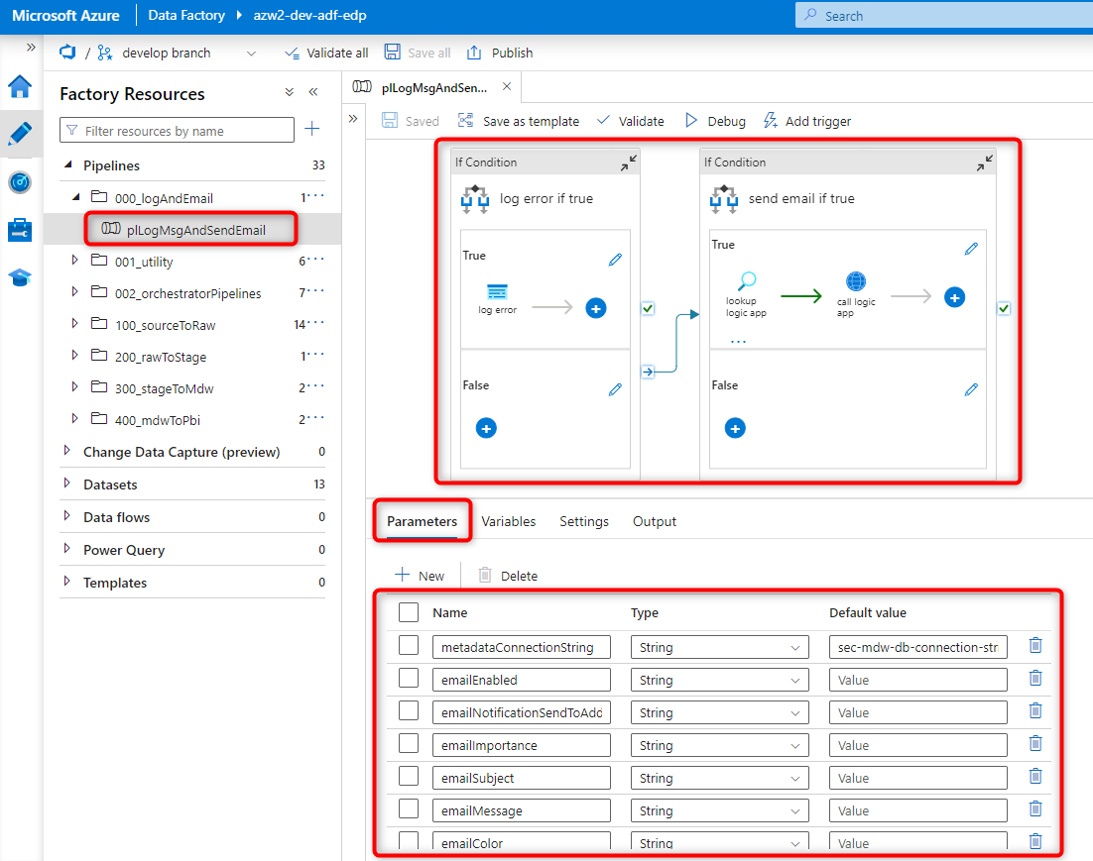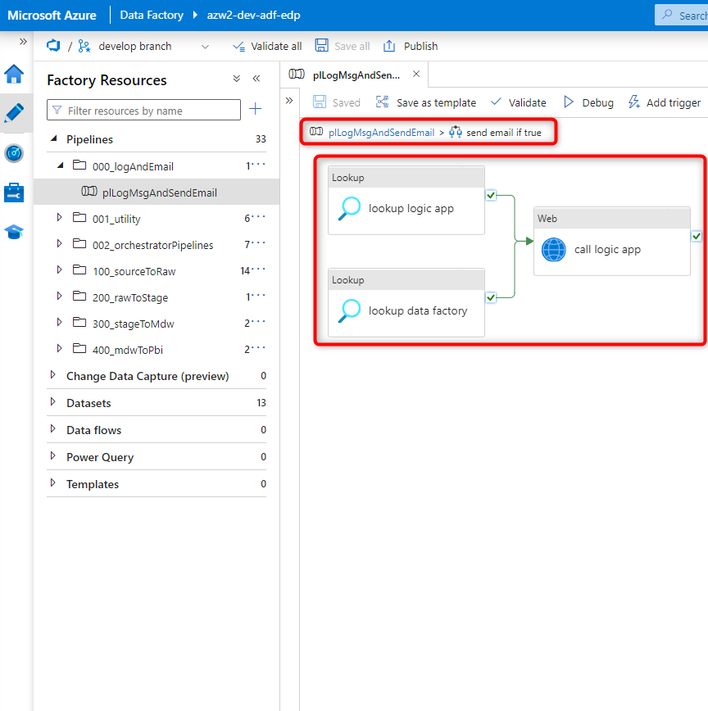

The steps below outline the workflow when an error occurs in ADF and how that error is handled:

1. When a pipeline or activity fails in ADF, it triggers the pipeline *plLogMsgAndSendEmail.*
2. This pipeline will log the error and then trigger the logic app to send an email.
3. Metadata used to trigger the logic app (the HTTP Post URL) and create the Datafactory monitor URL included in emails are stored in the metadata table *adf.azureResources*
4. A JSON request is sent to the Logic App with the following parameters:

* DataFactoryName
* EmailImportance
* EmailNotificationSendToAddress
* Email Subject
* PipelineName
* PipelineRunID
* EmailMessage

When the Logic App HTTP POST URL is triggered with the JSON request, it invokes the Logic App workflow below:

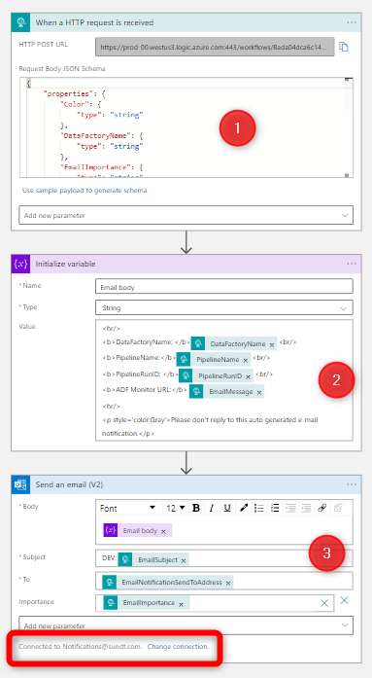

1. The last step of the Logic App workflow send an email to the list of recipient’s defined from your DataFactory pipeline, with the email coming from [Notifications@Sundt.com](mailto:Notifications@Sundt.com)

# Data Ingestion

## Infrastructure

The data platform uses a number of different pieces of infrastructure for data processing:

* **Orchestration:** ADF is used to orchestrate different activities for ingesting data data.
* **Data Connections:** ADF linked services are used to connect to different data sources.
* **Azure SQL Database:** Used to store metadata in ***adf***.***dataSource*** fordata store connection information and orchestration
* **Data Ingestion Compute:** Data Factory leverages integration runtimes as the compute to move data between data stores
* **Delta Table Compute:** Databricks high-concurrency spark clusters are used as the compute engine for converting the files that have been landed in the data lake to delta tables.
* **Storage:** Azure data lake (storage account with hierarchical namespace enabled) is used as the target to store all files and delta tables used in the data ingestion process.

**Summary:** The data platform uses Data Factory to ingest data at scale from both on-premises and cloud data systems. Data Factory leverages integration runtimes as the compute to move data between data stores in a secure, reliable, and high-performance manner. You can learn more about these integration runtime resources earlier in this documentation.

Data Factory copies data from different data sources at different intervals, or triggers, using the ***plSourceToBronze*** pipelines in ADF. These pipelines are dynamically populated with metadata that define what to connect to and what objects to copy from each data store. This metadata information is stored in the metadata database in the ***adf.dataSource*** table.

When data is copied from data stores, it is typically copied over and landed in the datalake raw container in parquet format (json, csv and xlsx files are landed in their same format). These files are then loaded into bronze delta tables (managed tables). The bronze layer is append only, meaning it only inserts data so that you can maintain a full history of the data from source.

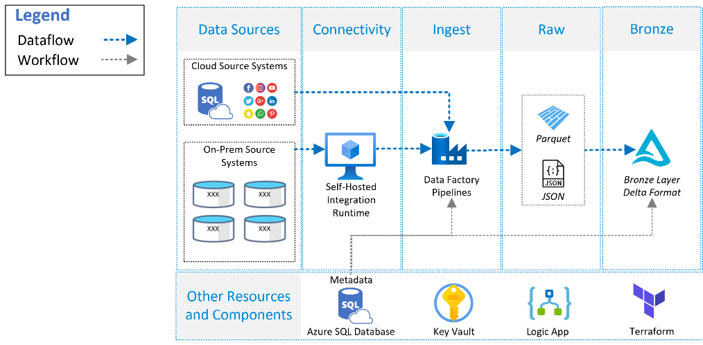

Figure 5 Data ingestion process and infrastructure pieces. The data sources in this diagram do not represent all data sources ingested.

## Orchestration and Metadata

Ingestion pipelines in ADF are organized by data source type and sometimes by data source for organization.

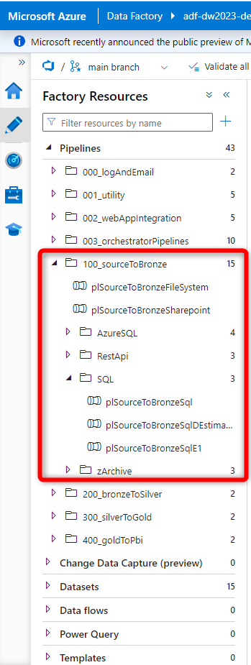

Figure 6 ADF ingestion pipelines

The general activities for each pipeline are generally the same. Each of these pipelines is orchestrated by metadata in the ***adf***.***dataSource*** table. The ***Lookup Activity and query*** in each pipeline selects the appropriate metadata for each data source from the ***adf.dataSource*** table for each pipeline.

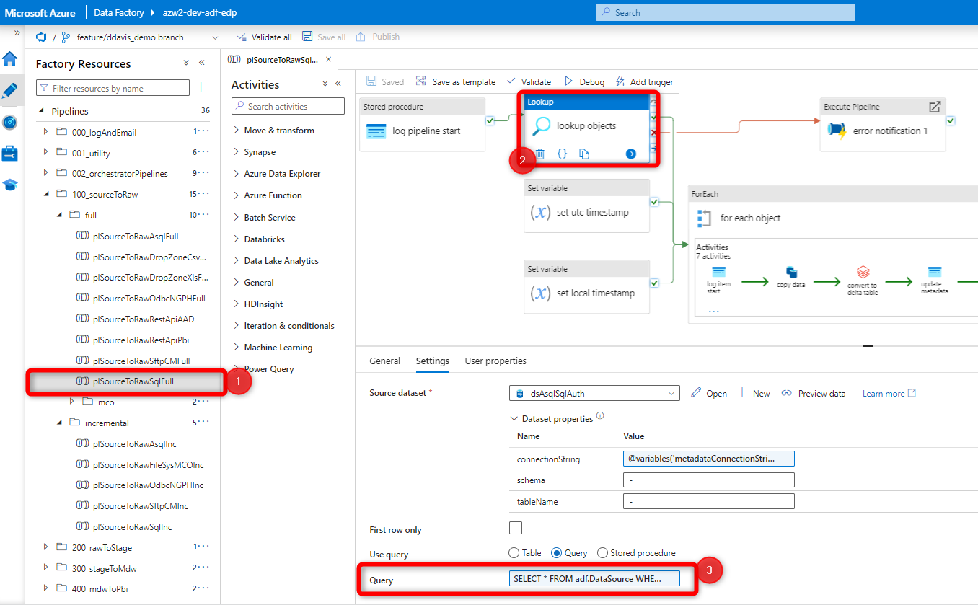

Figure 7 Example of the lookup activity query

Metadata is then dynamically passed into each pipeline activity using a ***ForEach activity*** to copy each object from the data store and land it in the target data lake. The ***ForEach*** ***inner*** ***loop*** is iterated through for each object returned in the ***Lookup Activity.*** Inside the ***ForEach*** ***inner*** ***loop***,the items property is used to populate activity parameters and is referred to by using the ***@item()*** syntax. The ***@item()*** property allows you to select values returned from the metadata that were retrieved by the ***Lookup Activity*** and pass them into different variables/parameters***.*** For example, ***@item().objectName*** will pass in the value of the object name returned from the metadata.

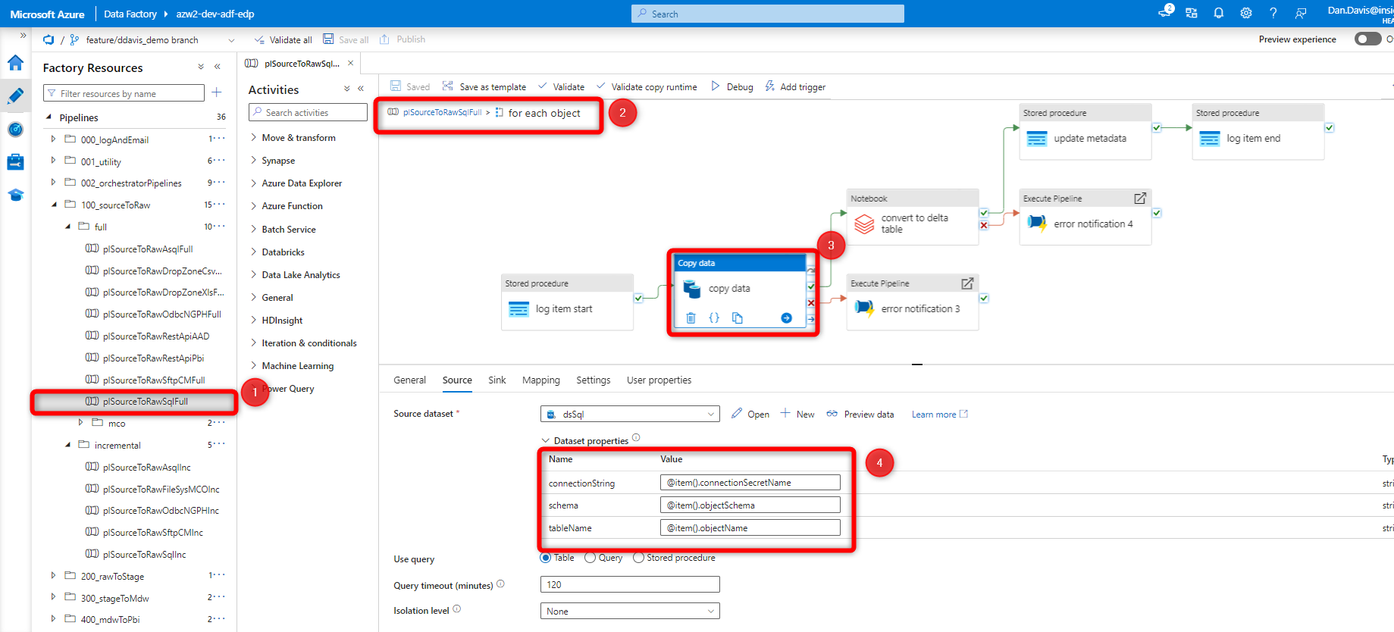

Figure 8 Example of a data ingestion pipeline showing the ForEach activity inner loop and how metadata items are dynamically passed into each activity to copy data

## Monitoring

### Azure Data Factory Monitoring

In the Azure Data Factory designer portal you will have four tabs named Home, Author, Monitor and Manage tab. You can see below in the screenshot.

Monitor tab of the Azure Data factory designer portal is the place where you need to go to monitor the Azure Data Factory. Once you get inside the monitor tab you will be greeted with the below screen.

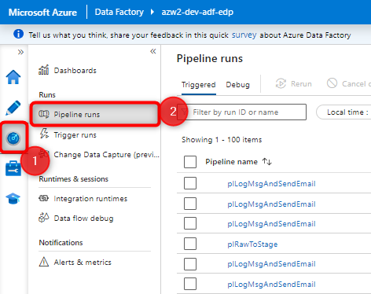

This is the default tab of the Azure Data factory monitor. Whatever be the pipeline that has been executed in your respective azure data factory account can be seen here. Here you have the filter available using which you can filter the pipeline run which you want to monitor. You can filter based on pipeline name, execution time, triggered by and many other filter criteria.

There is an option to sort the result based on the date time as well. You can click on the column name to sort the records in specific order.

In the pipeline run there are two tabs at the top of the page. One is for the **Triggered** and other is for the **Debug**. By default all the pipeline run display is for the execution initiated by the Triggers. In case if you want to see all the pipeline execution when you manually click the debug to run the pipeline, then you can see the logs for all the debug runs by clicking the debug tab in this same window.

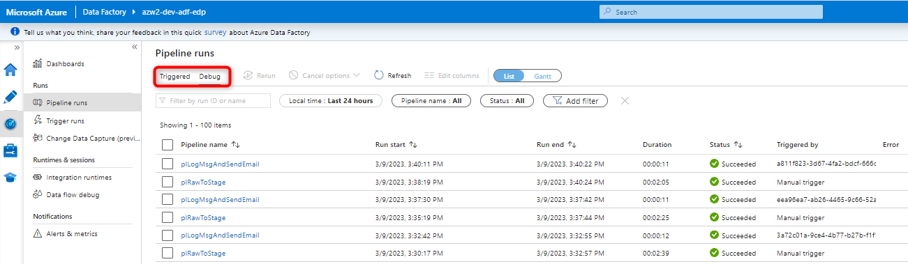

### Monitoring Self-Hosted Integration Runtime

Since the self-hosted integration runtime(s) are virtual machines, you can monitor them by using Azure Monitor.

#### What is Azure Monitor?

[Azure Monitor](https://learn.microsoft.com/en-us/azure/azure-monitor/overview) is a full stack monitoring service that provides a complete set of features to monitor your Azure resources. You don't need to directly interact with Azure Monitor, though, to perform a variety of monitoring tasks, because its features are integrated with the Azure portal for the Azure services that it monitors. For a tutorial with an overview of how Azure Monitor works with Azure resources, see [Monitor Azure resources by using Azure Monitor](https://learn.microsoft.com/en-us/azure/azure-monitor/essentials/monitor-azure-resource).

#### Monitoring virtual machine data

Azure virtual machines collect the same kinds of monitoring data as other Azure resources, which are described in [Monitoring data from Azure resources](https://learn.microsoft.com/en-us/azure/azure-monitor/insights/monitor-azure-resource#monitoring-data). For detailed information about the metrics and logs that are created by Azure virtual machines, see [Reference: Monitoring Azure virtual machine data](https://learn.microsoft.com/en-us/azure/virtual-machines/monitor-vm-reference).

#### Overview page

To begin exploring Azure Monitor, go to the **Overview** page for your virtual machine, and then select the **Monitoring** tab. You can see the number of active alerts on the tab.

The **Alerts** pane shows you the alerts fired in the last 24 hours, along with important statistics about those alerts. If there are no alerts configured for your VM, there is a link to help you quickly create new alerts for your VM.

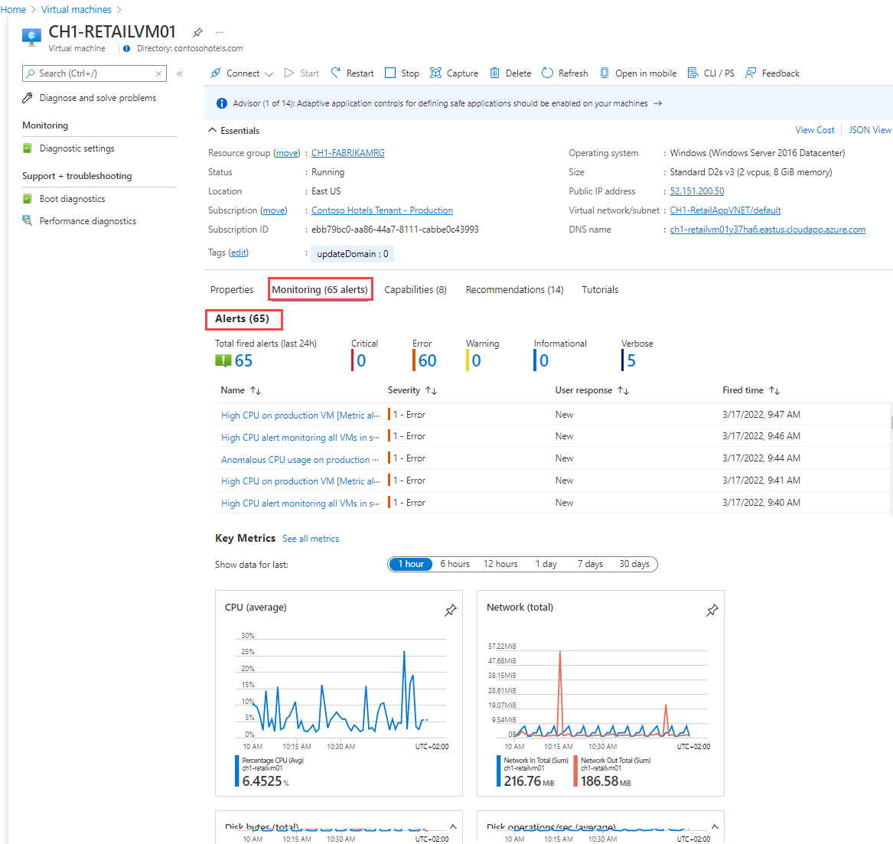

The **Key Metrics** pane includes charts that show key health metrics, such as average CPU and network utilization. At the top of the pane, you can select a duration to change the time range for the charts, or select a chart to open the **Metrics** pane to drill down further or to create an alert rule.

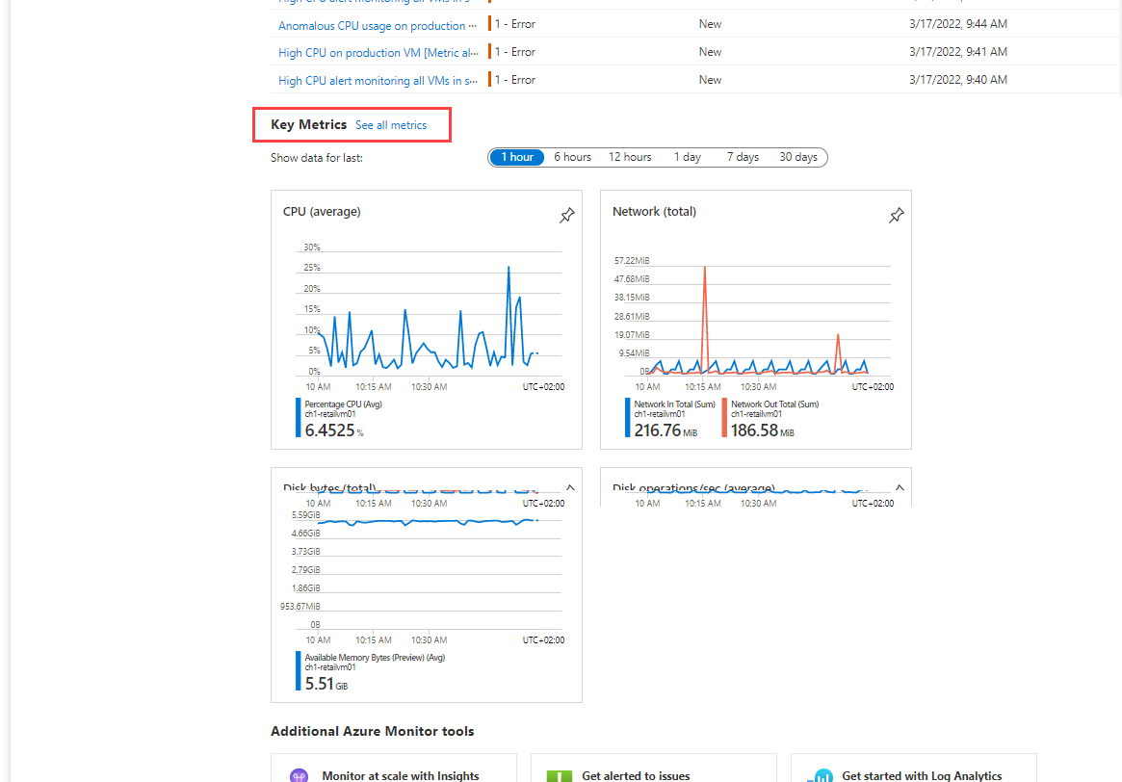

#### Activity log

The [Activity log](https://learn.microsoft.com/en-us/azure/azure-monitor/essentials/activity-log) displays recent activity by the virtual machine, including any configuration changes and when it was stopped and started. View the Activity log in the Azure portal, or create a [diagnostic setting to send it to a Log Analytics workspace](https://learn.microsoft.com/en-us/azure/azure-monitor/essentials/activity-log#send-to-log-analytics-workspace), where you can view events over time or analyze them with other collected data.

[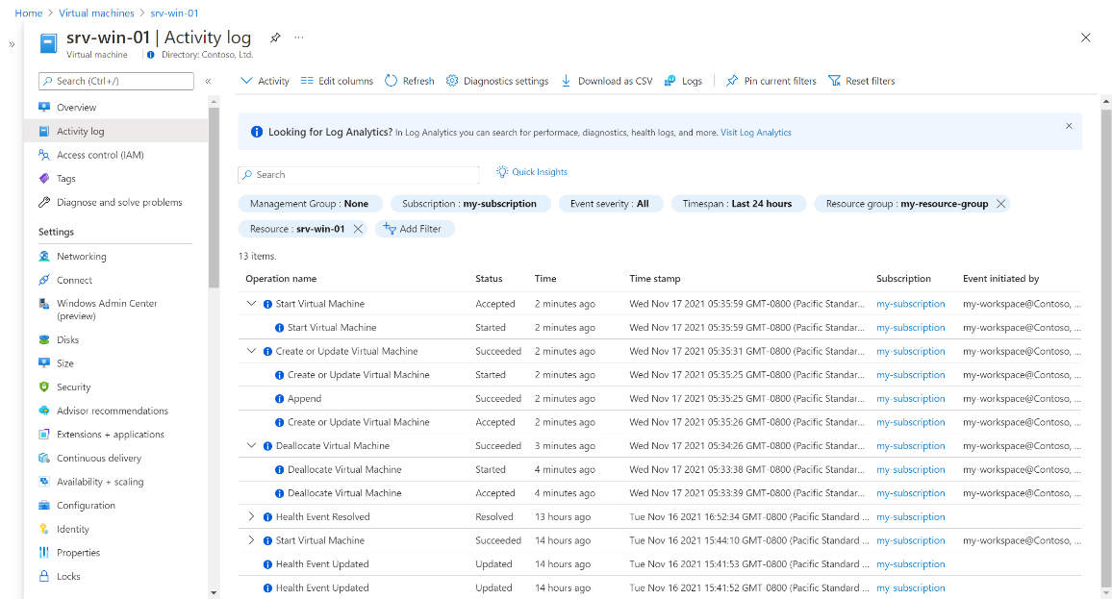](https://learn.microsoft.com/en-us/azure/virtual-machines/media/monitor-vm/activity-log.png#lightbox)

Azure Monitor starts automatically collecting metric data for your virtual machine host when you create the VM. To collect logs and performance data from the guest operating system of the virtual machine, though, you must install the [Azure Monitor agent](https://learn.microsoft.com/en-us/azure/azure-monitor/agents/azure-monitor-agent-overview). You can install the agent and configure collection using either [VM insights](https://learn.microsoft.com/en-us/azure/virtual-machines/monitor-vm#vm-insights) or by [creating a data collection rule](https://learn.microsoft.com/en-us/azure/virtual-machines/monitor-vm#create-data-collection-rule) as described below.

### Azure Data Factory Log Views

All of the ADF pipelines and activities are logged in the table ***adf.executionLog*** in the metadata database***.*** There are several SQL views that denoramlize the ***adf.executionLog*** so that you can view each object or pipeline that has been executed, how long it took to run, the average time it takes to run, and the number of records during the execution. These views can be used to monitor execution times of individual objects or data pipelines over time. The screenshot below shows the different SQL views in the metadata database:

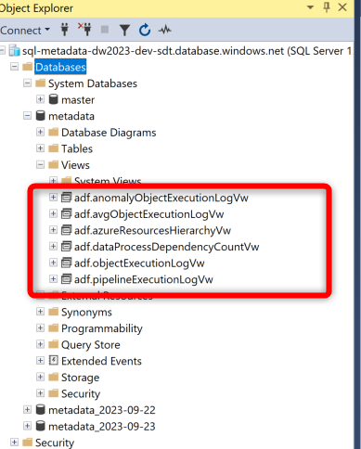

Figure 9 Example of different SQL views used for monitoring

## Tuning and Performance

### Self-Hosted Integration Runtime

When using the self-hosted integration runtime to ingest data, you can increase the size for better performance.

The development and test ADF share the same self-hosted integration runtime. The production ADF uses it’s own integration runtime.

|  |  |
| --- | --- |
| **Environment** | **Name and IP Address** |
| Dev/Test Integration Runtime | TEMADFDEV02 10.10.12.30 |
| Prod Integration Runtime | TEMADFPRD02 10.10.12.31 |

These integration runtimes were provisioned by Garret Reed at Sundt. Please reach out to him for configuration details or further administration.

### ADF Batch Size

If you have multiple ingestion pipelines running concurrently or batch sizes that are too large, this can drastically hinder performance of the self-hosted integration runtime. Please schedule ingestion pipelines accordingly so they don’t all execute at the same time, and then toggle the batch size of the ***ForEach*** activity to limit how many objects are copied in parallel.

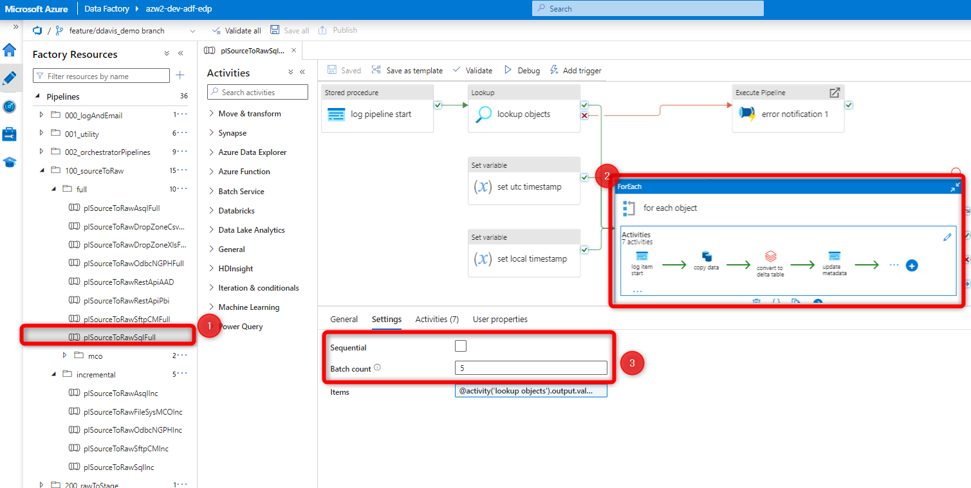

Figure 10 Example of an ingestion pipeline and how to adjust the batch count for a ForEach activity.

## Governance

By default, anybody that has contributor access to ADF can ingest data by triggering a pipeline.

In Databricks, only users in the ***admins, data_engineering_admins, and data_engineering_users*** group can access the Databricks data engineering environment and have access to all Delta tables and databases. Users with access to the SQL Warehouse that do not belong to the ***admins*** group do not have access to the Delta tables, rather they have access to the dynamic views that enforce row-level security. Databricks groups and governance is discussed later in the documentation here.

Since connection string and connection information is stored in the Azure Key Vault, only users with access to the key vault and with certain ***access policies***can access these secrets.

# Data Processing

## Infrastructure

Thedata platform uses a number of different pieces of infrastructure for data processing:

* **Orchestration:** ADF used to orchestrate different activities for processing data.
* **Azure SQL Database:** Used to store metadata in ***adf***.***dataProcess*** and ***adf.dataProcessDependency*** for orchestration
* **Compute:** Databricks high-concurrency spark clusters are used as the compute engine for processing data. One cluster is used for executing notebooks and processing data while a separate table access cluster is used to assign table access to users/groups to different delta tables and databases.
* **Storage:** Azure data lake (storage account with hierarchical namespace enabled) is used to store all files and delta tables used in data processing.

Data Factory executes different pipelines for processing data (e.g. executing Databricks notebooks) at different intervals, or triggers, using the ***plBronzeToSilver or plSilverToGold*** pipelines in ADF. These pipelines are dynamically populated with metadata that define what to execute and the order in which to execute them. This metadata information is stored in the metadata database in the ***adf.dataProcess and adf.dataProcessDependency*** table.

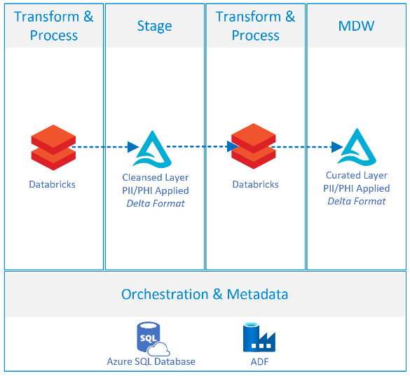

## Orchestration and Metadata

### Azure Data Factory

Data Processing pipelines in ADF are broken out into the different layers that they process, which includes ***WebAppIntegration,*** ***SourceToBronze***, ***BronzeToSilver, SilverToGold, and GoldToPBI***

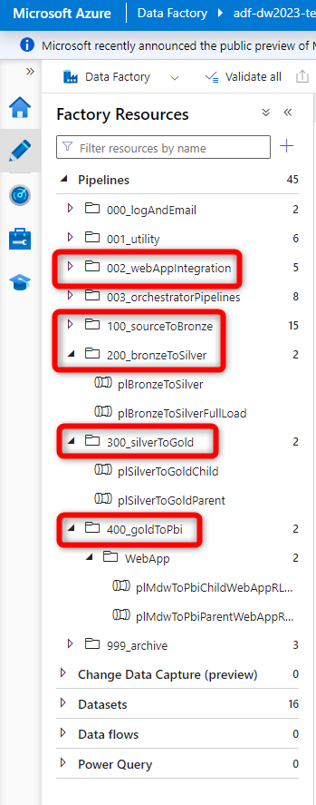

Figure 11 ADF data processing pipelines

##### Bronze To Silver

The ***plBronzeToSilver*** pipeline processes tables from raw and into the stage layer. It handles PII information while also doing some data cleansing. This pipeline is orchestrated by metadata in the ***adf***.***dataProcess*** table. The ***Lookup Activity and stored procedure*** (stored procedure is called ***adf.getDataProcessDependency***) in the pipeline selects the appropriate metadata for each object from the ***adf.dataProcess*** table that needs to be executed.

**Note:** If the parameter inthe ***plBronzeToSilver*** pipeline called ***isTableRefreshedRequired*** is set to ***True,*** then the pipeline will omit any tables that do not need to be updated, which is determined by comparing the ***adf.dataProcess.lastExecutionTimestamp*** to ***adf.dataSource.lastExecutionTimestamp***. If you set ***isTableRefreshedRequired = False*** then this setting will be ignored. By default, this parameters is set to FALSE for triggers. This is primarily a legacy feature that is rarely used.

Metadata is then dynamically passed into each pipeline activity using a ***ForEach activity*** to copy each object from the data store and land it in the target data lake. The ***ForEach*** ***inner*** ***loop*** is iterated through for each object returned in the ***Lookup Activity.*** Inside the ***ForEach*** ***inner*** ***loop***,the items property is used to populate activity parameters and is referred to by using the ***@item()*** syntax. The ***@item()*** property allows you to select values returned from the metadata that were retrieved by the ***Lookup Activity*** and pass them into different variables/parameters***.*** For example, ***@item().objectName*** will pass in the value of the object name returned from the metadata. moose

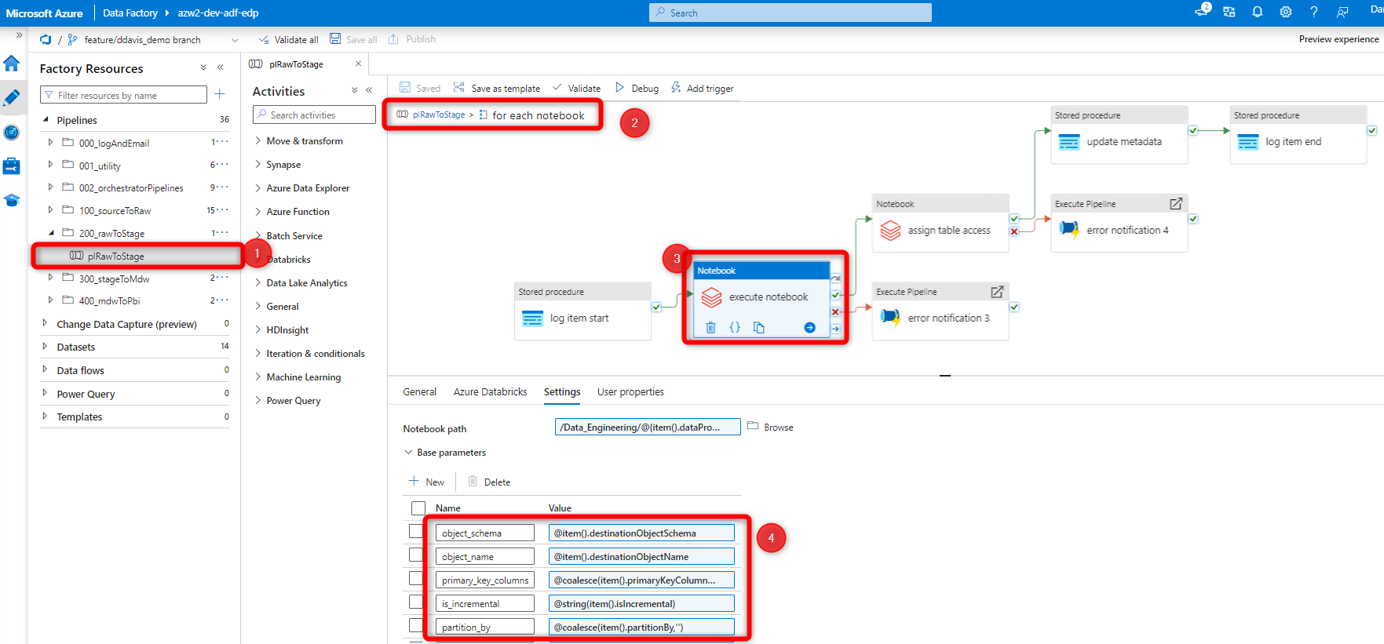

Figure 12 Figure 8 Example of a data ingestion pipeline showing the ForEach activity inner loop and how metadata items are dynamically passed into each activity to copy data

##### Silver To GOLD

The ***plStageToGold*** pipelines process tables from stage and create our dimension and fact tables in the Gold layer. These pipeline are orchestrated by metadata in the ***adf***.***dataProcess and adf***.***dataProcessDependency*** table.

**plSilverToGoldParent:**

* This pipeline executes a plSilverToGoldChild pipeline. It executes the child pipelines for each level in the hierarchy returned in the stored procedure ***adf.uspGetProcessDependencyHierarchyLevels.*** So if there are 10 different levels of dependencies in the hierarchy generated by ***adf.dataProcessDependency,*** then this pipeline will execute 10 different child pipelines in order of dependency (e.g. level 1, then level 2, then level 3, etc.). Each level of the hierarchy is executed sequentially, as defined in the ***sequential*** ***setting*** on the ***ForEach activity***.

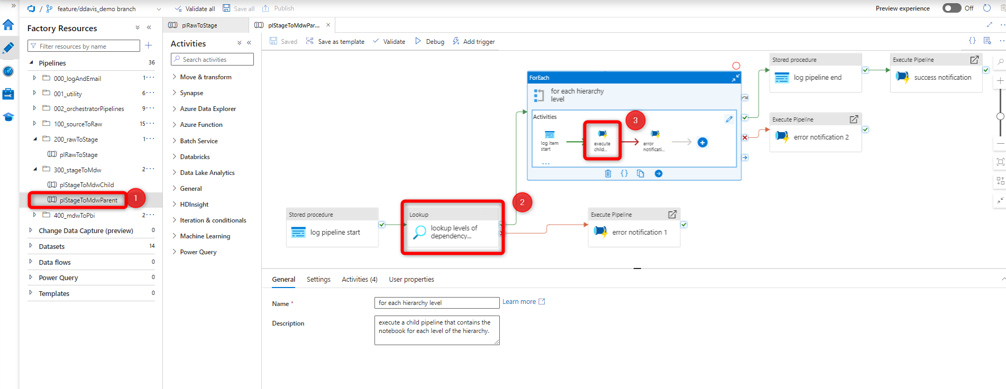

Figure 13 Parent pipeline showing how it looks up the different levels of the hierarchy and then executes a child pipeline for each level.

**plSilverToGoldChild:**

* This pipeline executes the objects, or notebooks, for a given level of the hierarchy. So if a child pipeline is executed by the parent pipeline for level 1, then the child pipeline will execute all objects in level 1 (this could be 100 tables). The ***Lookup Activity and stored procedure*** (stored procedure is called ***adf.getDataProcessDependency***) in the pipeline selects the appropriate metadata for each object from the ***adf.dataProcess*** table that needs to be executed. This metadata will execute the appropriate Databricks notebook to execute each table.

##### GOLD To PBI

The ***plGoldToPbi*** pipelines process datasets in Power BI. These pipeline are orchestrated by metadata in the ***adf***.***powerBiDatasets*** metadata table.

**plGoldToPbiParent:**

This pipeline looks up the Power BI dataset ID’s in the ***adf***.***powerBiDatasets*** table. Then, it executes the child pipeline for each dataset returned in the ***Lookup Activity***.

**plGoldtoPbiChild:**

This pipeline refreshes a Power BI dataset. This pipeline will trigger a dataset refresh, wait until that refresh finishes, and then indicate whether the refresh either succeeded or failed. This pipeline requires that a service principal be created and added as an ADMIN on the PBI workspace of the dataset you wish to refresh. This pipeline also requires that you store the service principal client id and secret in the key vault. It also requires that you store the key vault URI, PBI dataset ID, and PBI workspace ID in the metadata table called ***adf.powerBiDatasets***. It then uses this metadata to connect and authenticate to the [Power BI REST API](https://learn.microsoft.com/en-us/rest/api/power-bi/datasets/refresh-dataset) and refresh a datasets.

**Note:** The Power BI service principal information is stored in the SDAT key vault (e.g. kv-sdat-dev-sdt). ADF has a connection to the corresponding SDAT key vault for that particular environment and uses the Power BI secrets from there. This means that ALL Power BI service principal credentials are stored in the SDAT key vaults under the secrets for *pbier-client-id* *and pbier-client-secret*.

## Creating Dimension and Fact Tables

Dimension and fact tables are created using Databricks notebooks, and using templates to ensure consistency, and re-usable code wrapped in function. This helps reduce code being re-written across multiple places.

When creating a new table, you can clone a new template to the appropriate folder in the ***300_SilverToGold*** directory and follow the instructions in the template for defining the table and business logic to create a dimension or fact table. The templates for creating tables are located in Databricks in the following path: ***notebooks/data_engineering/300_silver_to_gold /templates/silver_to_gold_dim_template***

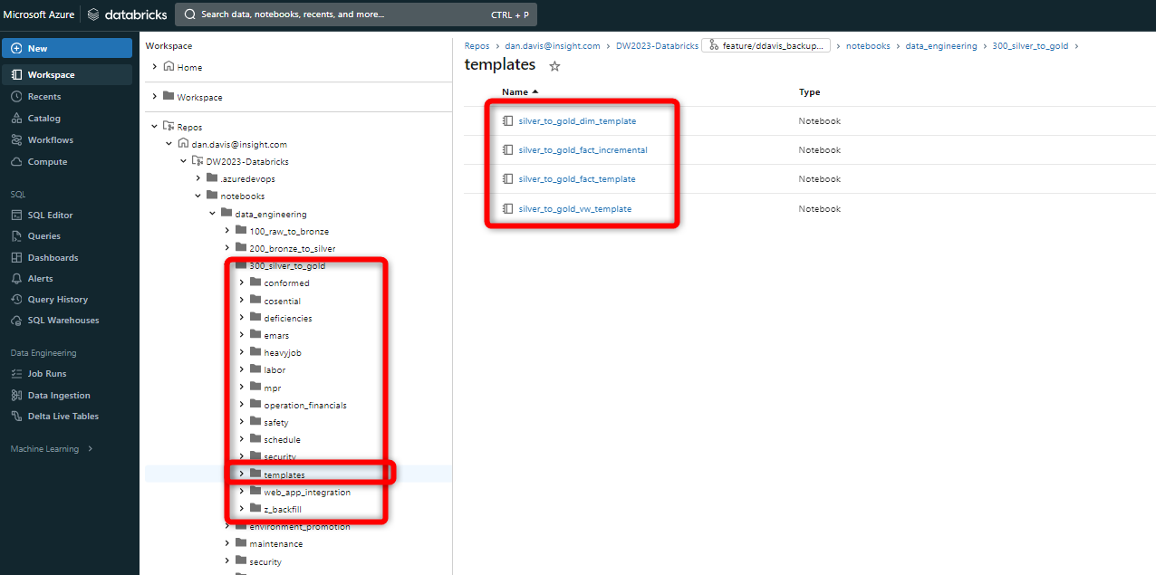

Figure 14 Showing where the table templates in Databricks live

## Databricks Functions and Classes

There are a number of common python functions and other pieces of reusable code through the Databricks environment. Pieces of reusable code like functions are stored in notebooks in the utility folder: *data_engineering/utility*

Most functions are stored in the common_functions notebook in *data_engineering/utility/* *common_functions.*

This notebook is references and imported by almost every single notebook in the Databricks environment using [%run](https://docs.databricks.com/en/notebooks/notebook-workflows.html#use-run-to-import-a-notebook). This notebook imports necessary libraries used throughout our environment, therefore we can make changes in a single place. This notebook also defines common functions used throughout the environment. For example, the function for assigning RLS (function name: *assign_rls_by_project_number*) is stored in this notebook and heavily commented for documentation.

### User-Defined Functions

A user-defined function ([UDF](https://docs.databricks.com/en/udf/index.html)) is a function defined by a user, allowing custom logic to be reused in the user environment. Databricks has support for many different types of UDFs to allow for distributing extensible logic. This article introduces some of the general strengths and limitations of UDFs.

These functions are stored in *data_engineering/utility/*user_defined_functions. This notebook must be imported by other notebooks in order to use user-defined-functions.

For example, the UDF for converting Julian Dates is stored in this notebook:

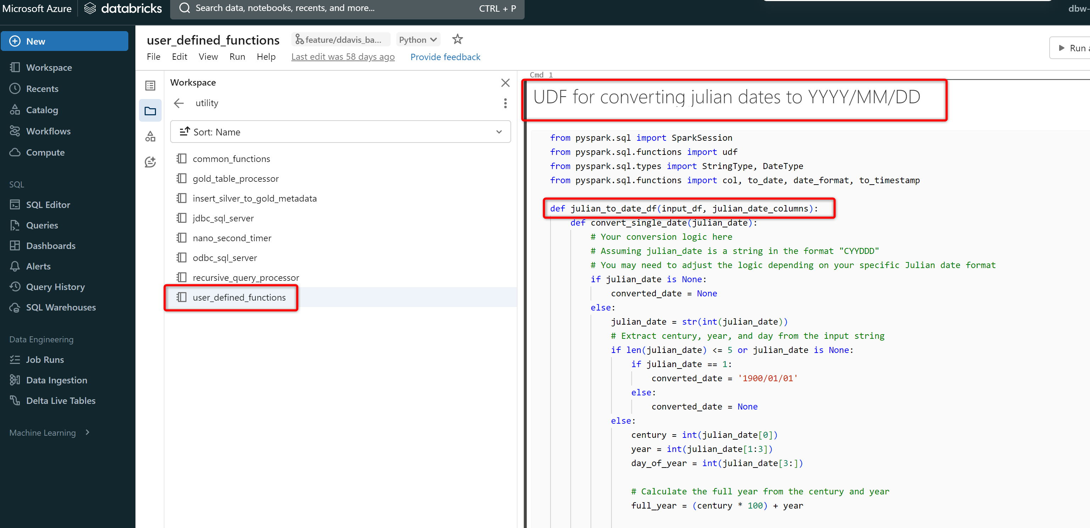

### Python Classes

The other notebooks in the utility folder represent [python classes](https://www.w3schools.com/python/python_classes.asp). They are very verbose and the names of the notebooks represent the class purpose. A python class which is a collection of functions all used to perform operations on a single object.

The most commonly used class, which is used in all of the silver_to_gold notebooks, is the gold_table_processor. This class contains code for performing operations on dimensions and fact tables (e.g. add surrogate key by creating a key store).

## Web App Pipelines

There are several tables that the data warehouse populates in the web app:

* Web App table: dbo.workspaces
  + The data warehouse removes workspaces/reports that have been deleted or the service principal no longer has access too and then add new workspaces/reports.
* Web App table: dbo.UserMenu (overrides only!!!)
  + The data warehouse removes contacts access to workspaces/reports that have been deleted or the service principal no longer has access too (both overrides and non overrides). Then it updates overrides to give them access to new workspaces/reports.
* Web App table: dbo.CompanySettings
  + Data warehouse removes companies that have been deleted and inserts new companies.

Below are the steps in which these tables are populated:

1. The notebooks used to create the export used for populating these tables are in Databricks located at: */data_engineering/300_silver_to_gold/web_app_integration* and these produce Delta tables in the *web_app_integration* database.
2. In order to load the tables into the web app database, we cannot load Delta tables directly into a SQL database very easily. Therefore the notebooks also create a parquet export of these tables and place them in the datalake in the adf-staging container:

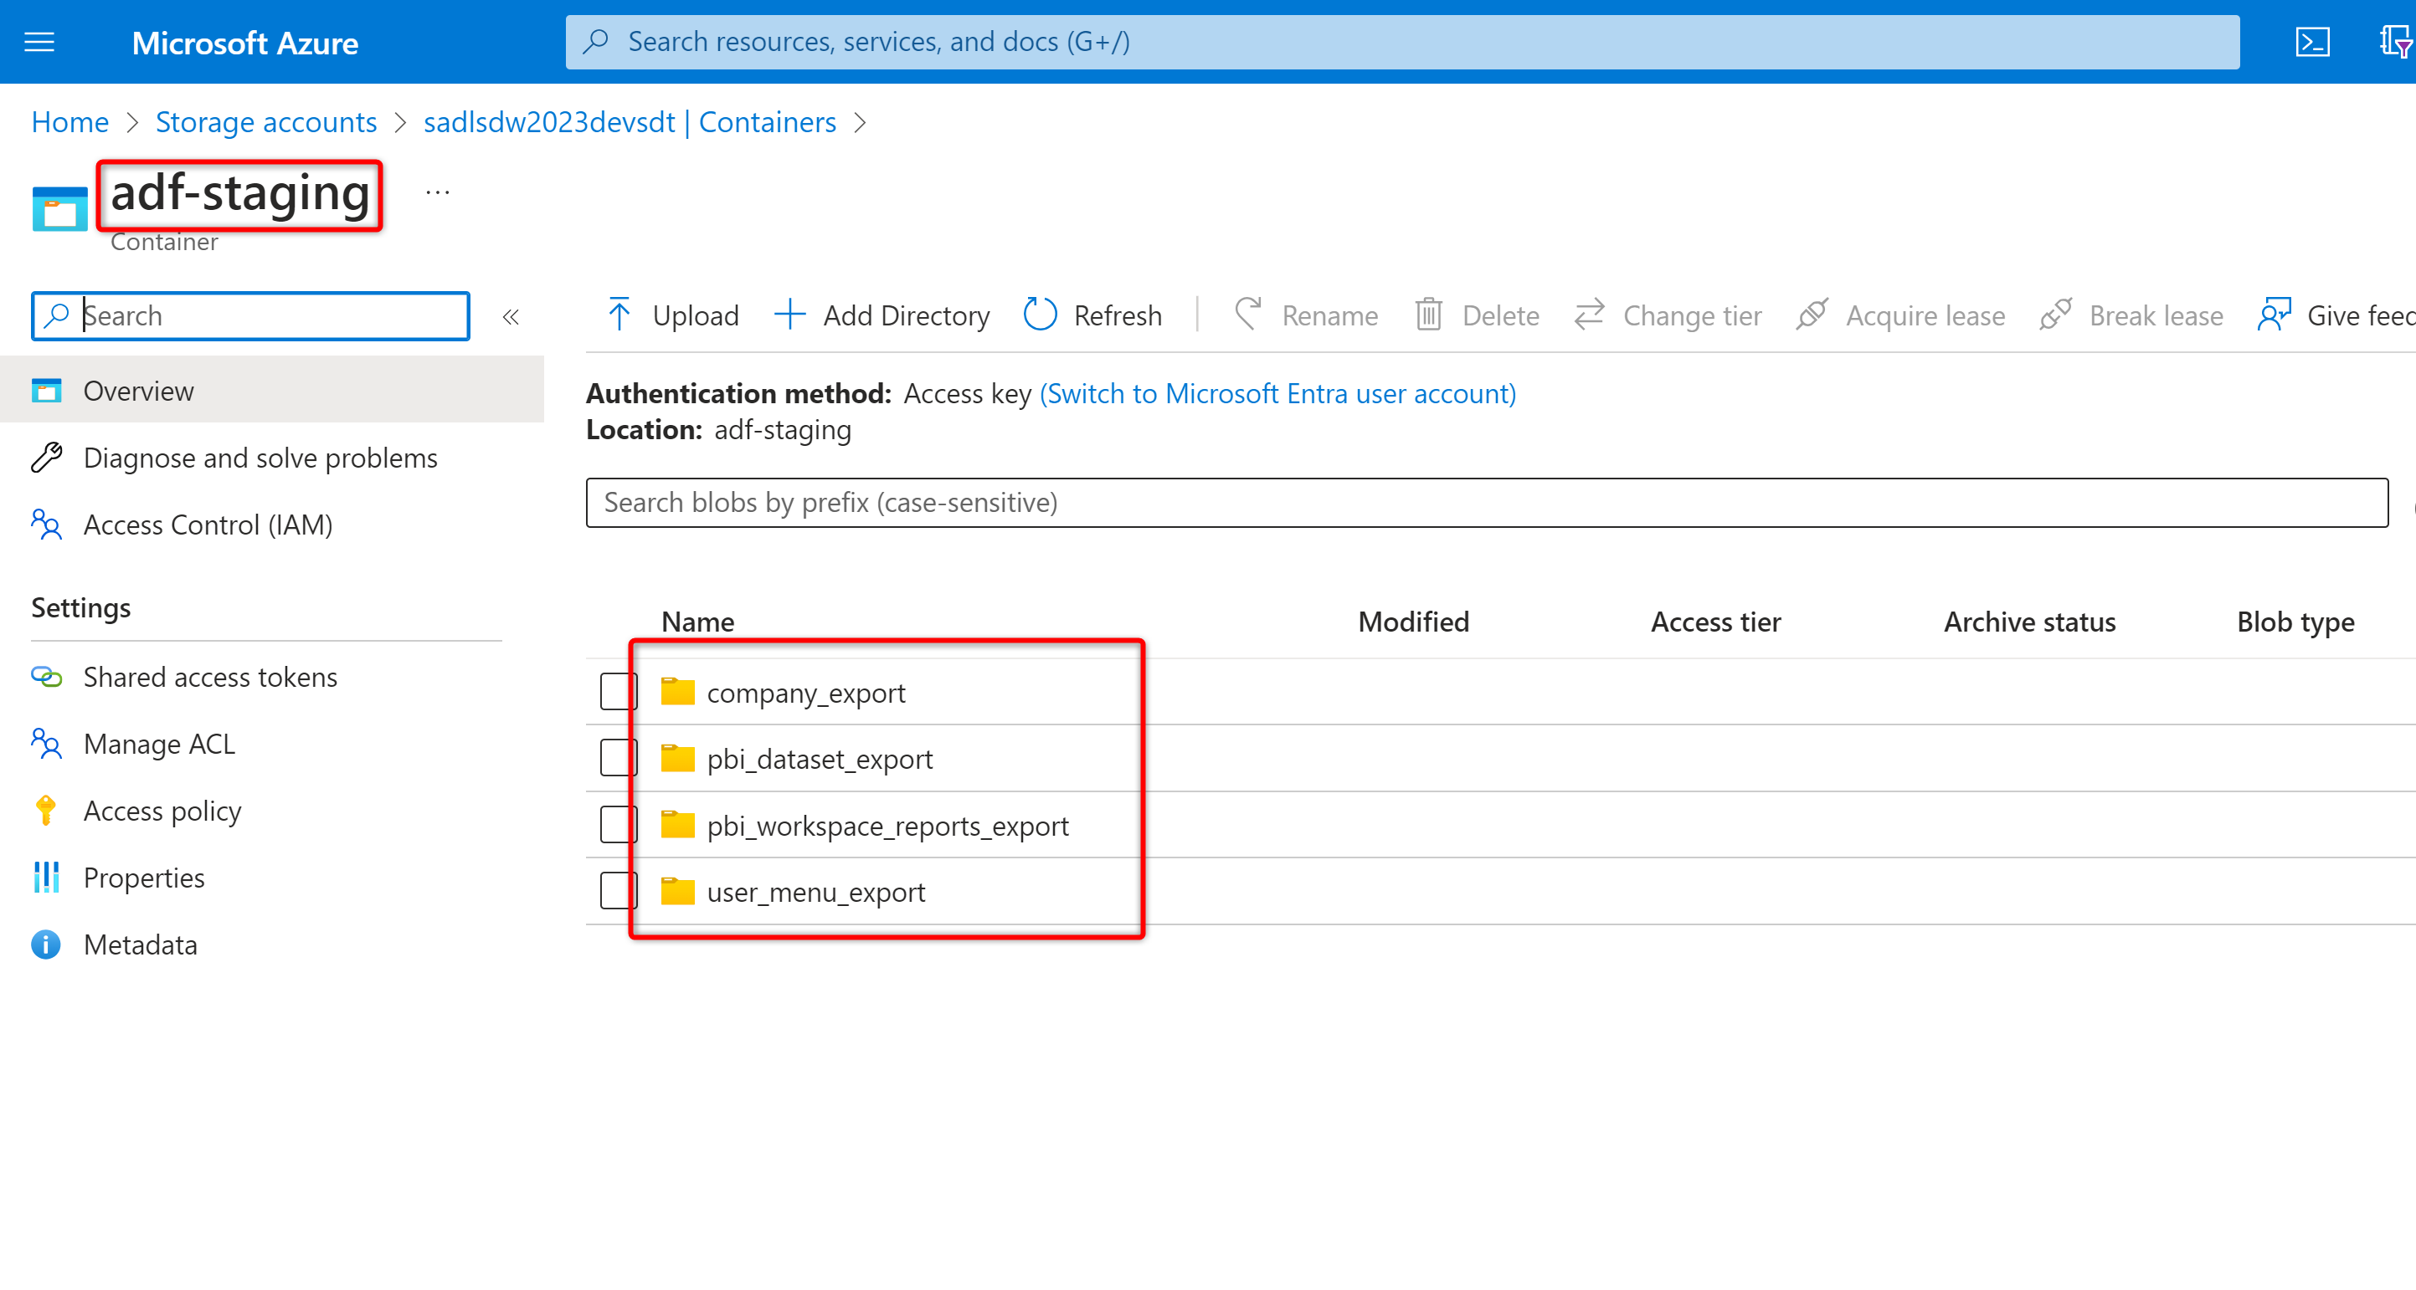

1. The corresponding Data Factory pipeline takes these exports and loads them into the web app tables. The Data Factory pipelines for the different tables can be seen below in the *002_webAppIntegrationFolder*

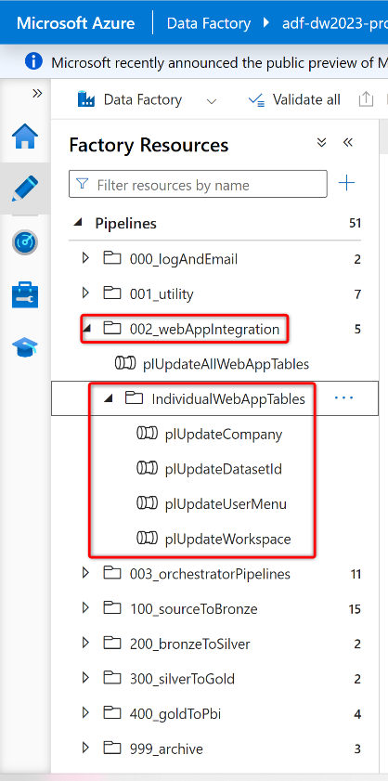

The plUpdateDataSetId is pipeline is not used to populate anything in the Web App database. Rather it populates the ***adf.powerBiDatasets*** table in the data warehouse metadata database.

1. The pipeline *plUpdateAllWebAppTables* will execute all of the Databricks notebooks to update the exported parquet files, and then run the individual web app tables in the correct order to update the web app database.

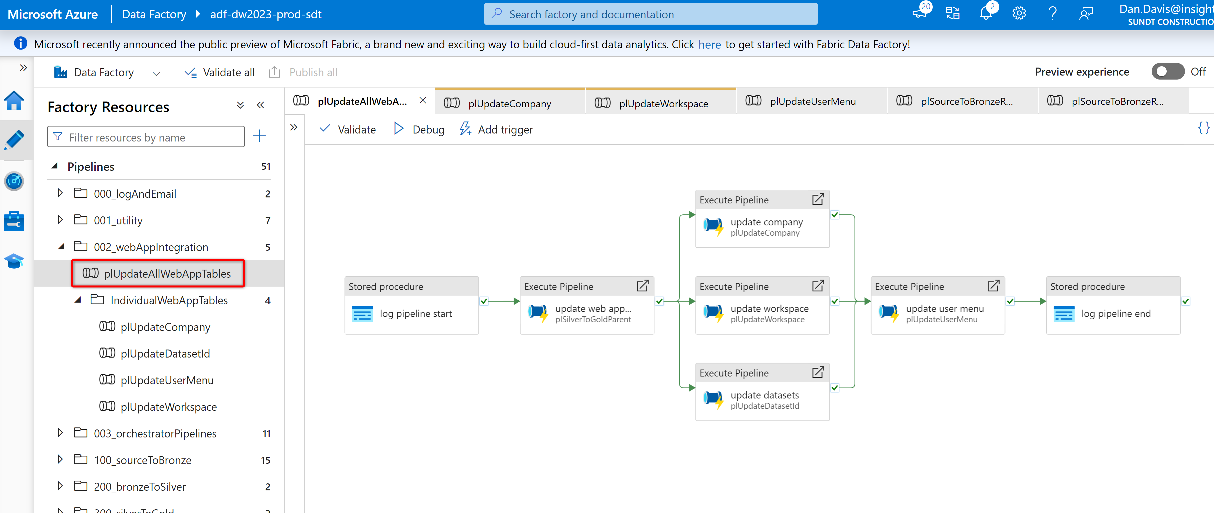

1. The pipeline *plWebAppUpdatePBIDatasetsFrequenyUpdates* will load necessary tables to update all of the RLS tables (dim_active_directory_user, stg_user_project_relationship, bridge_user_project_relationship) in the data warehouse, and then update the power bi pipelines to refresh the dataset. This pipeline can be configured to run at more frequent intervals so that new contacts added in InEight and Cosential will be updated in the Power BI datasets for RLS.
2. The pipeline *plWebAppUpdateSecurityAndWebAppIntegration* willload necessary tables to update all of the RLS tables (dim_active_directory_user, stg_user_project_relationship, bridge_user_project_relationship) in the data warehouse, and then update the power bi pipelines to refresh the dataset. It will also update all of the tables in the web app with new workspaces, overrides, and companies. This pipeline is generally just run on-demand and is not scheduled to run.

## Monitoring

As part of the engagement, a Power BI report was created for more visual ETL Monitoring. This PBIX file lives in Teams under [Sundt Data Warehouse 2023 - > Sundt ETL Monitoring Report](https://sundtconstruction.sharepoint.com/:u:/r/teams/SundtDataWarehouse2023/Shared%20Documents/Data%20Warehouse/Sundt%20ETL%20Monitoring%20Report.pbix?csf=1&web=1&e=KOuDRh)

### Azure Data Factory Monitoring

In the Azure Data Factory designer portal you will have four tabs named Home, Author, Monitor and Manage tab. You can see below in the screenshot.

Monitor tab of the Azure Data factory designer portal is the place where you need to go to monitor the Azure Data Factory. Once you get inside the monitor tab you will be greeted with the below screen.



This is the default tab of the Azure Data factory monitor. Whatever be the pipeline that has been executed in your respective azure data factory account can be seen here. Here you have the filter available using which you can filter the pipeline run which you want to monitor. You can filter based on pipeline name, execution time, triggered by and many other filter criteria.

There is an option to sort the result based on the date time as well. You can click on the column name to sort the records in specific order.

In the pipeline run there are two tabs at the top of the page. One is for the **Triggered** and other is for the **Debug**. By default all the pipeline run display is for the execution initiated by the Triggers. In case if you want to see all the pipeline execution when you manually click the debug to run the pipeline, then you can see the logs for all the debug runs by clicking the debug tab in this same window.



### Azure Data Factory Log Views

All of the ADF pipelines and activities are logged in the table ***adf.executionLog*** in the metadata database***.*** There are several SQL views that denoramlize the ***adf.executionLog*** so that you can view each object or pipeline that has been executed, how long it took to run, the average time it takes to run, and the number of records during the execution. These views can be used to monitor execution times of individual objects or data pipelines over time. The screenshot below shows the different SQL views in the metadata database:

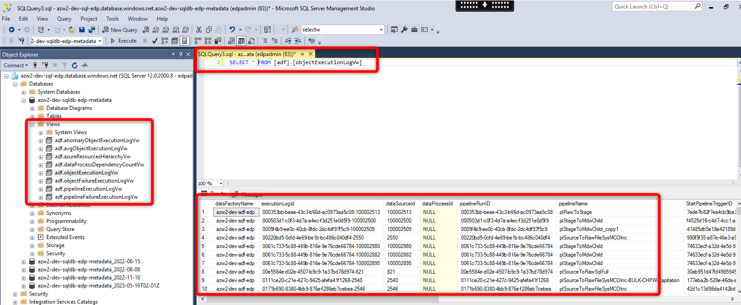

Figure 15 Example of different SQL views used for monitoring

## Tuning and Performance

### Databricks Clusters

#### Monitor Performance

To help you monitor the performance of Databricks clusters, Databricks provides access to metrics from the cluster details page.

To view the cluster metrics UI:

1. Click **Compute** in the sidebar.
2. Click on the compute resource you want to view metrics for.
3. Click the **Metrics** tab.

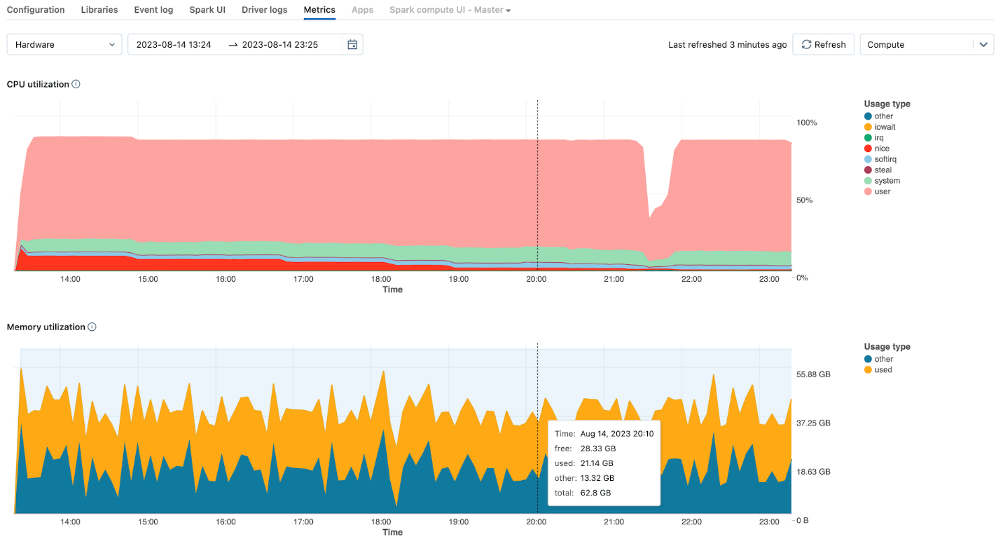

Hardware metrics are shown by default. To view Spark metrics, click the dropdown labeled **Hardware** and select **Spark**. You can also select **GPU** if the instance is GPU-enabled.

#### Autoscaling

Autoscaling automatically adds and removes worker nodes in response to changing workloads to optimize resource usage. With autoscaling enabled, Databricks automatically chooses the appropriate number of workers required to run your Spark job. Autoscaling makes it easier to achieve high cluster utilization as you do not need to worry about the exact provisioning of cluster to match workloads. This can offer two advantages: (1) The workloads can run faster compared to running a constant sized under-provisioned cluster. (2) You can reduce overall costs compared to a statically sized cluster.

When you enable autoscaling, you can specify the minimum and maximum number of nodes in the cluster. Setting this range for the number of workers requires some experimenting. Ad-hoc usage or business analytics will generally have a large variance. For production batch jobs, you can leave autoscaling off or add a buffer on the upper limit.

The image below shows where you can enable the autoscaling feature, along with changing the min/max number of workers in the cluster configuration

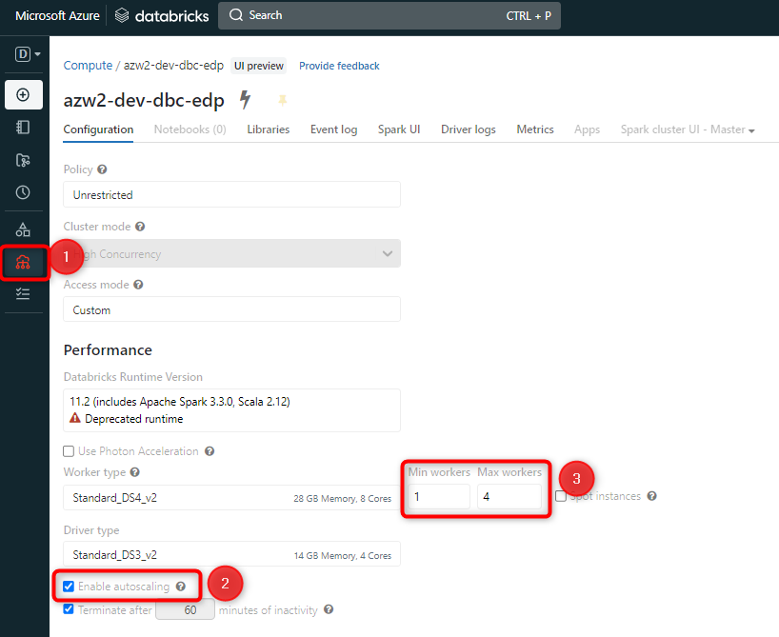

Figure 16 Cluster configuration window with settings to adjust autoscaling

#### Terminate a Cluster

To save cluster resources, you can terminate a cluster. The terminated cluster’s configuration is stored so that it can be reused (or, in the case of jobs, autostarted) at a later time. You can manually terminate a cluster or configure the cluster to automatically terminate after a specified period of inactivity. When the number of terminated clusters exceeds 150, the oldest clusters are deleted.

Unless a cluster is pinned or restarted, it is automatically and permanently deleted 30 days after termination.

Terminated clusters appear in the cluster list with a gray circle at the left of the cluster name.

**Manual termination**

You can manually terminate a cluster from the cluster list (by clicking the square on the cluster’s row) or the cluster detail page (by clicking Terminate).

**Automatic termination**

You can also set auto termination for a cluster. During cluster creation, you can specify an inactivity period in minutes after which you want the cluster to terminate.

If the difference between the current time and the last command run on the cluster is more than the inactivity period specified, Databricks automatically terminates that cluster.

A cluster is considered inactive when all commands on the cluster, including Spark jobs, Structured Streaming, and JDBC calls, have finished executing. This does not include commands run by SSH-ing into the cluster and running bash commands.

The image below shows where to access the setting to automatically terminate a cluster after XX minutes of inactivity:

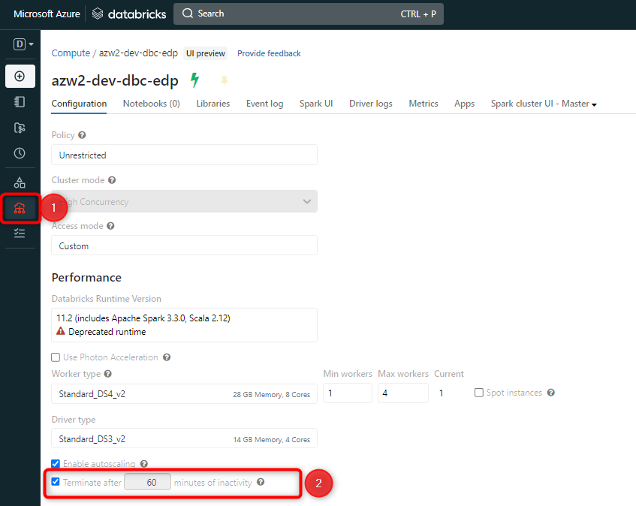

Figure 17 Cluster termination settings

### ADF Batch Size

If you have multiple data processing pipelines running concurrently or batch sizes that are too large, this can drastically hinder performance of the Databricks cluster that is processing notebooks. Please schedule pipelines accordingly so they don’t all execute at the same time, and then toggle the batch size of the ***ForEach*** activity to limit how many objects are copied in parallel.

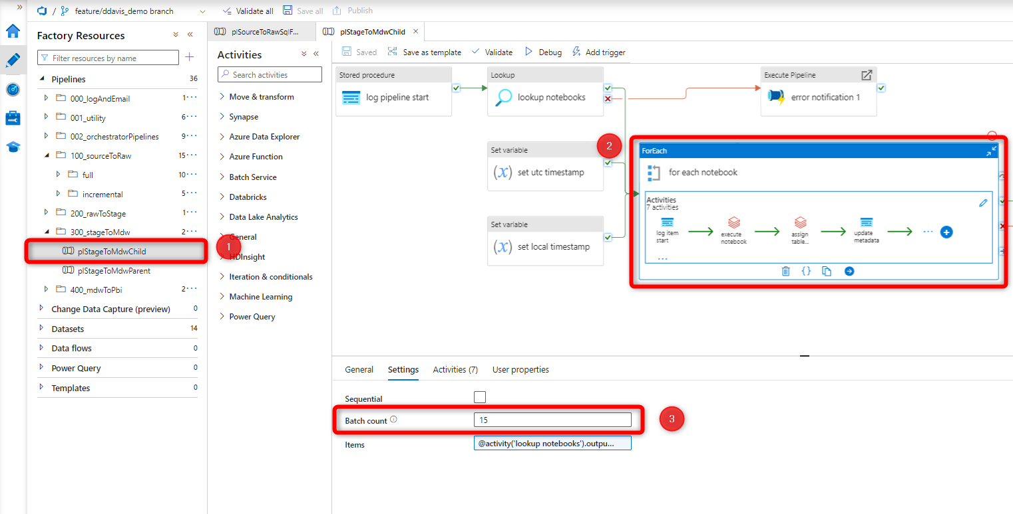

Figure 18 Example of an ingestion pipeline and how to adjust the batch count for a ForEach activity.

### Delta Table Performance Tuning

There are a number of different ways that you can add performance tuning features to Delta Tables:

* **OPTIMIZE:** Optimizes the layout of Delta Lake data. Optionally optimize a subset of data or colocate data by column. If you do not specify colocation, bin-packing optimization is performed. OPTIMIZE can help expedite processing tables that use merges, and can especially help accelerate the processing of key store tables. There is a notebook that should be run periodically to OPTIMIZE ALL TABLES and is located at ***/data_engineering/maintenance/maintenance_optimize_all_tables.*** You can learn more about [OPTIMIZE here.](https://docs.databricks.com/sql/language-manual/delta-optimize.html)
* **Z-ORDER:** Data skipping information is collected automatically when you write data into a Delta table. Delta Lake on Databricks takes advantage of this information (minimum and maximum values) at query time to provide faster queries. You do not need to configure data skipping; the feature is activated whenever applicable. However, its effectiveness depends on the layout of your data. For best results, apply Z-Ordering.
* By default Delta Lake on Databricks collects statistics on the first 32 columns defined in your table schema. You can change this value using the table property delta.dataSkippingNumIndexedCols. Adding more columns to collect statistics would add more overhead as you write files. You can learn more about [Z-Order here.](https://docs.databricks.com/delta/data-skipping.html) There is a notebook that should be run periodically to OPTIMIZE AND ZORDER the notebooks located at ***/data_engineering/maintenance/maintenance_and_zorder.*** The notebook to execute all of these zorder related notebooks is located at ***/data_engineering/maintenance/maintenance_execute_notebooks_in_optimize_folder.***

There is an ADF pipeline that executes these notebooks once per month. This ADF pipeline is called: ***plMonthlyMaintenance.***

* **Partitions:** A partition is composed of a subset of rows in a table that share the same value for a predefined subset of columns called the partitioning columns. Using partitions can speed up queries against the table as well as data manipulation.
* To use partitions, you define the set of partitioning column when you create a table by including the PARTITIONED BY clause. You can learn more about [partitions here.](https://docs.databricks.com/sql/language-manual/sql-ref-partition.html)
* **VACUUM:** Recursively vacuum directories associated with the Delta table. VACUUM removes all files from the table directory that are not managed by Delta, as well as data files that are no longer in the latest state of the transaction log for the table and are older than a retention threshold. VACUUM will skip all directories that begin with an underscore (_), which includes the _delta_log. Partitioning your table on a column that begins with an underscore is an exception to this rule; VACUUM scans all valid partitions included in the target Delta table. Delta table data files are deleted according to the time they have been logically removed from Delta’s transaction log plus retention hours, not their modification timestamps on the storage system. The default threshold is 7 days.
* On Delta tables, Databricks does not automatically trigger VACUUM operations.
* It is important to run VACUUM otherwise you can incur unnecessary costs on your data lake for old, unused data files.
* If you run VACUUM on a Delta table, you lose the ability to time travel back to a version older than the specified data retention period.
* There is a notebook that should be run periodically to OPTIMIZE ALL TABLES and is located at ***/data_engineering/maintenance/maintenance_vacuum_all_tables.***
* There is an ADF pipeline that executes these notebooks once per month. This ADF pipeline is called: ***plMonthlyMaintenance.***

# Governance

## The Unity Catalog object model

In Unity Catalog, the hierarchy of primary data objects flows from metastore to table or volume:

* **Metastore**: The top-level container for metadata. Each metastore exposes a three-level namespace (catalog.schema.table) that organizes your data.
  + **Sundt Metastore**: westus_metastore
* **Catalog**: The first layer of the object hierarchy, used to organize your data assets.
  + **Sundt Catalogs:** There is a catalog for each environment: dev, test and prod.
* **Schema**: Also known as databases, schemas are the second layer of the object hierarchy and contain tables and views.
* **Volume**: Volumes sit alongside tables and views at the lowest level of the object hierarchy and provide governance for non-tabular data.
* **Table**: At the lowest level in the object hierarchy are tables and views.
  + **Sundt Tables**: All tables have been created as managed tables in Unity catalog.

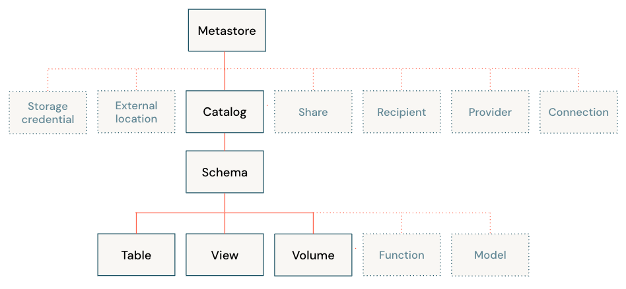

## Metastores

A metastore is the top-level container of objects in Unity Catalog. It stores metadata about data assets (tables and views) and the permissions that govern access to them. Azure Databricks account admins should create one metastore for each region in which they operate and assign them to Azure Databricks workspaces in the same region. For a workspace to use Unity Catalog, it must have a Unity Catalog metastore attached.

Each metastore is configured with a managed storage location in an Azure Data Lake Storage Gen2 container in your Azure account. See [Managed storage](https://learn.microsoft.com/en-us/azure/databricks/data-governance/unity-catalog/#managed-storage).

**Note:** This metastore is distinct from the Hive metastore included in Azure Databricks workspaces that have not been enabled for Unity Catalog. If your workspace includes a legacy Hive metastore, the data in that metastore will still be available alongside data defined in Unity Catalog, in a catalog named hive_metastore. Note that the hive_metastore catalog is not managed by Unity Catalog and does not benefit from the same feature set as catalogs defined in Unity Catalog. See [Create a Unity Catalog metastore](https://learn.microsoft.com/en-us/azure/databricks/data-governance/unity-catalog/create-metastore).

## Managed storage

When an account admin creates a metastore, they must associate a storage location in an Azure Data Lake Storage Gen2 container in your Azure account to use as **managed storage**. Unity Catalog also allows users to associate managed storage locations with catalogs and schemas.

Managed storage has the following properties:

* Managed tables and managed volumes store data and metadata files in managed storage.
* Managed storage cannot overlap with external tables, external volumes, or other managed storage.

The following table describes how managed storage is declared and associated with Unity Catalog objects:

|  |  |  |
| --- | --- | --- |
| **Associated Unity Catalog object** | **How to set** | **Relation to external locations** |
| Metastore | Configured by account admin during metastore creation. | Cannot overlap an external location. |
| Catalog | Specified during catalog creation using the LOCATION keyword. | Must be contained within an external location. |
| Schema | Specified during schema creation using the LOCATION keyword. | Must be contained within an external location. |

The managed storage location used to store data and metadata for managed tables and managed volumes uses the following rules:

* If the containing schema has a managed location, the data is stored in the schema managed location.
* If the containing schema does not have a managed location but the catalog has a managed location, the data is stored in the catalog managed location.
* If neither the containing schema nor the containing catalog have a managed location, data is stored in the metastore managed location.

## Storage credentials and external locations

To manage access to the underlying cloud storage for external table, external volumes, and managed storage, Unity Catalog introduces the following object types:

* **Storage credentials** encapsulate a long-term cloud credential that provides access to cloud storage. For example, an [Azure managed identity](https://learn.microsoft.com/en-us/azure/databricks/data-governance/unity-catalog/azure-managed-identities) that can access an Azure Data Lake Storage Gen2 container.
* **External locations** contain a reference to a storage credential and a cloud storage path.

See [Manage external locations and storage credentials](https://learn.microsoft.com/en-us/azure/databricks/data-governance/unity-catalog/manage-external-locations-and-credentials).

External Locations

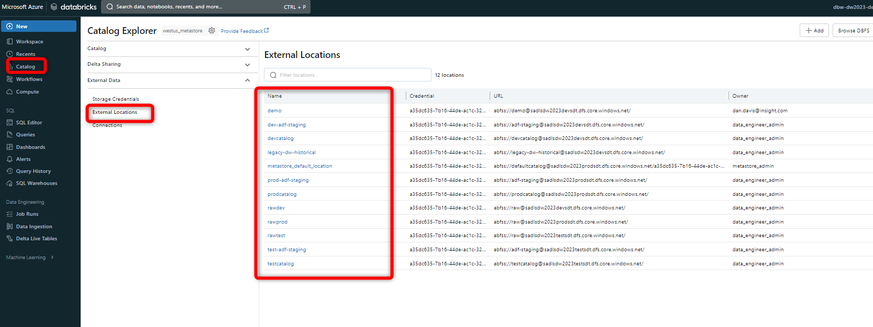

Figure 19 Sundt External Locations

Sundt Storage Credentials:

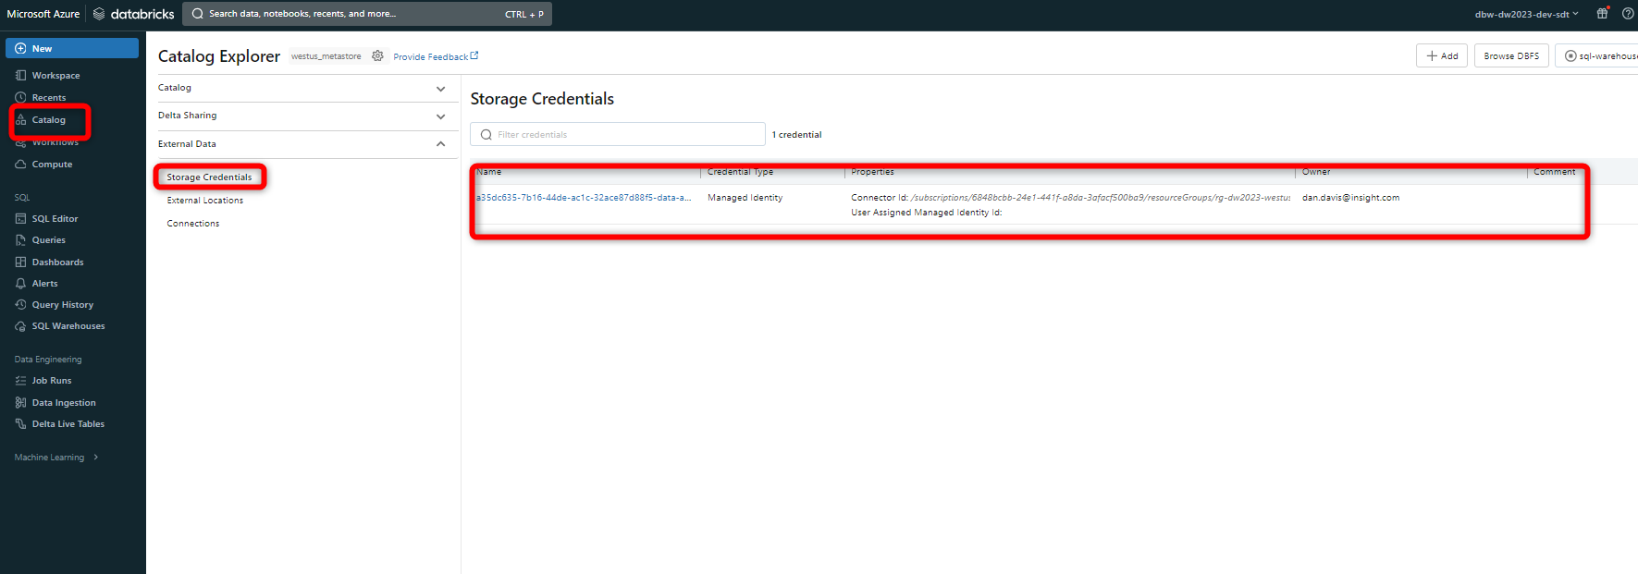

Figure 20 Sundt storage credentials

[Unity Catalog](https://learn.microsoft.com/en-us/azure/databricks/data-governance/unity-catalog/) can be configured to use an [Azure managed identity](https://learn.microsoft.com/en-us/azure/active-directory/managed-identities-azure-resources/overview) to access storage containers on behalf of Unity Catalog users. Managed identities provide an identity for applications to use when they connect to resources that support Azure Active Directory (Azure AD) authentication.

**Sundt Databricks Access Connector for Authentication:** dbw-ac-dw2023-prod-sdt

You can use managed identities in Unity Catalog to support two primary use cases:

* As an identity to connect to the metastore’s managed storage accounts (where managed tables are stored).
* As an identity to connect to other external storage accounts (either for file-based access or for accessing existing datasets through external tables).

## Catalogs

A catalog is the first layer of Unity Catalog’s three-level namespace. It’s used to organize your data assets. Users can see all catalogs on which they have been assigned the USE CATALOG [data permission](https://learn.microsoft.com/en-us/azure/databricks/data-governance/unity-catalog/manage-privileges/).

All users have the USE CATALOG permission on the main catalog. The main catalog is intended for organizations that are just getting started with Unity Catalog. As you add users and data, you should add catalogs to maintain a data hierarchy that enables efficient control over access.

See [Create and manage catalogs](https://learn.microsoft.com/en-us/azure/databricks/data-governance/unity-catalog/create-catalogs).

Sundt has a catalog for each respective environment: dev, test, prod.

## Schemas

A schema (also called a database) is the second layer of Unity Catalog’s three-level namespace. A schema organizes tables and views. Users can see all schemas on which they have been assigned the USE SCHEMA permission, along with the USE CATALOG permission on the schema’s parent catalog. To access or list a table or view in a schema, users must also have SELECT permission on the table or view.

See [Create and manage schemas (databases)](https://learn.microsoft.com/en-us/azure/databricks/data-governance/unity-catalog/create-schemas).

## Tables

A table resides in the third layer of Unity Catalog’s three-level namespace. It contains rows of data. To create a table, users must have CREATE and USE SCHEMA permissions on the schema, and they must have the USE CATALOG permission on its parent catalog. To query a table, users must have the SELECT permission on the table, the USE SCHEMA permission on its parent schema, and the USE CATALOG permission on its parent catalog.

A table can be managed or external.

### Managed tables

Managed tables are the default way to create tables in Unity Catalog. Unity Catalog manages the lifecycle and file layout for these tables. You should not use tools outside of Azure Databricks to manipulate files in these tables directly.

By default, managed tables are stored in the root storage location that you configure when you create a metastore. You can optionally specify managed table storage locations at the catalog or schema levels, overriding the root storage location. Managed tables always use the [Delta](https://learn.microsoft.com/en-us/azure/databricks/delta/) table format.

When a managed table is dropped, its underlying data is deleted from your cloud tenant within 30 days.

See [Managed tables](https://learn.microsoft.com/en-us/azure/databricks/data-governance/unity-catalog/create-tables#managed-table).

### External tables

External tables are tables whose data lifecycle and file layout are not managed by Unity Catalog. Use external tables to register large amounts of existing data in Unity Catalog, or if you require direct access to the data using tools outside of Azure Databricks clusters or Databricks SQL warehouses.

When you drop an external table, Unity Catalog does not delete the underlying data. You can manage privileges on external tables and use them in queries in the same way as managed tables.

External tables can use the following file formats:

* DELTA
* CSV
* JSON
* AVRO
* PARQUET
* ORC
* TEXT

See [External tables](https://learn.microsoft.com/en-us/azure/databricks/data-governance/unity-catalog/create-tables#external-table).

### Access to Tables and Views

Access to tables and views is not dynamically assigned, rather it is inherited via the database/schema that object lives in.

Databases/Schemas with Delta tables (no row-level security applied) live in databases *without* the *_v* suffix (e.g. conformed). Only members of the data_engineer_admin and data_engineer_user have access to tables within these databases. Access to the tables in these databases is inherited from the database in which we apply permissions:

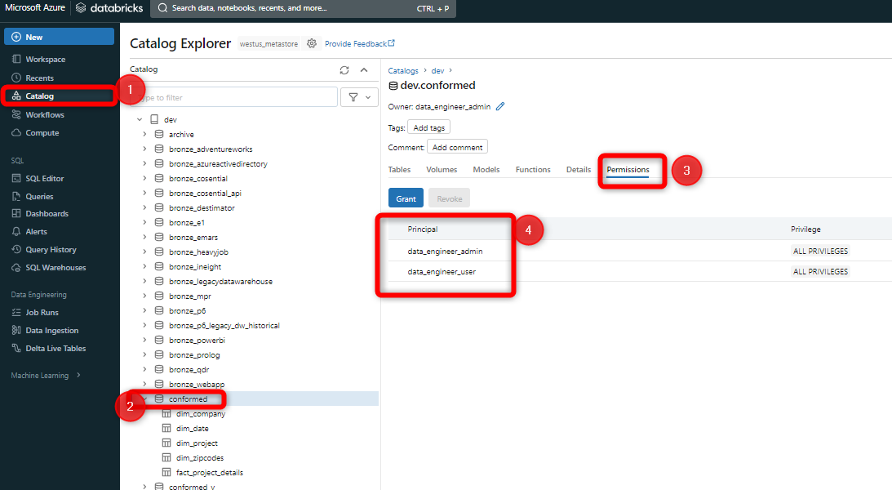

Figure 21 Figure showing how data engineers are assigned access to databses that contain Delta tables

Users that have row-level security applied and only access the datawarehouse to query tables, only have access to dynamic views. These dynamic views live in databases with the suffix *_v* (e.g. conformed_v). Access to the views in these databases is inherited from the database in which we apply permissions:

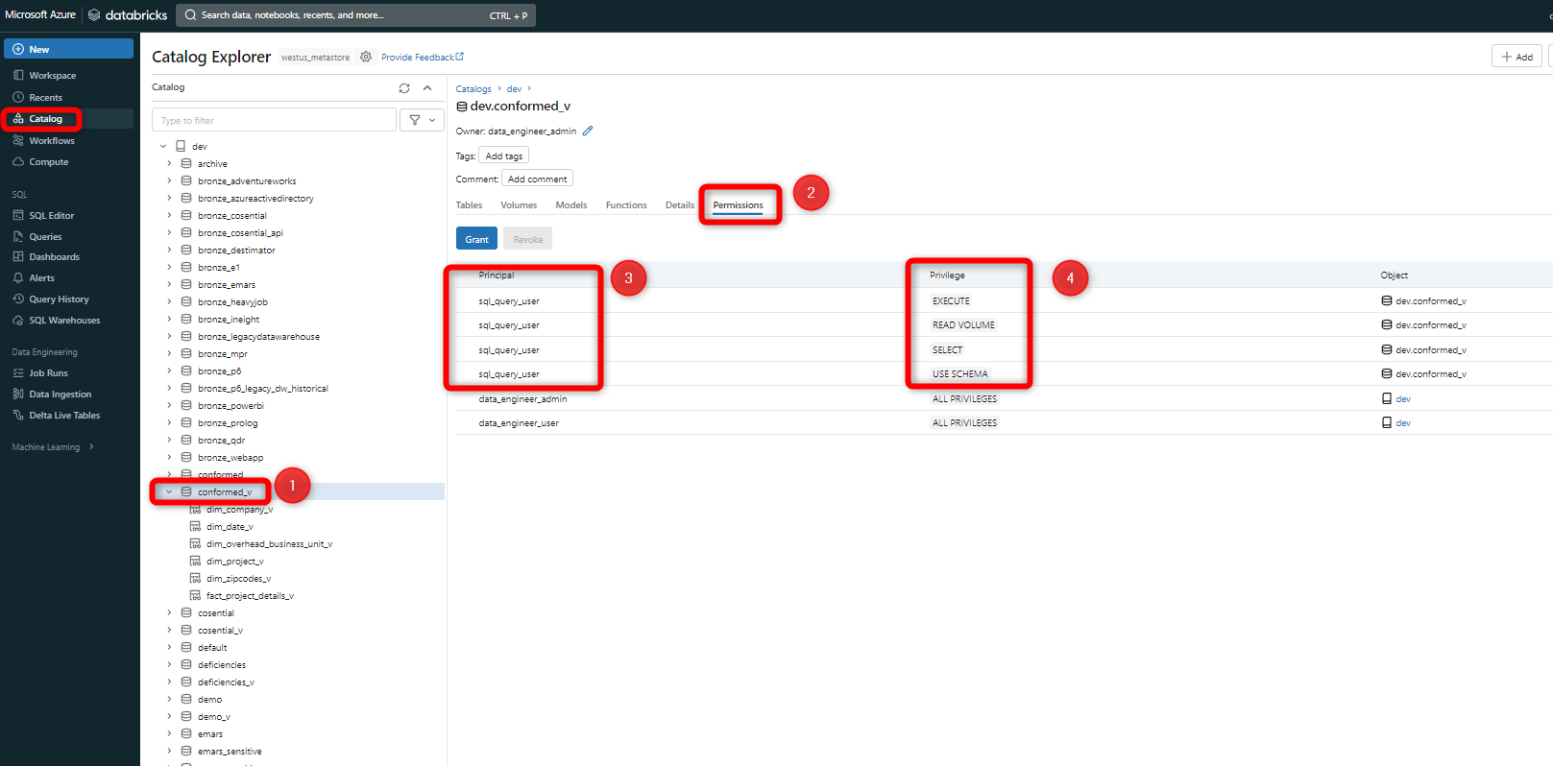

Figure 22 Figure showing how users are assigned access to databses that contain dynamic views that enforce RLS

Groups are added to these databases with the *Data Reader* preset. Also, if you add new databases, these groups have to explicitly be added to these databases in order to access them. Groups do not inherit access to new databases by default.

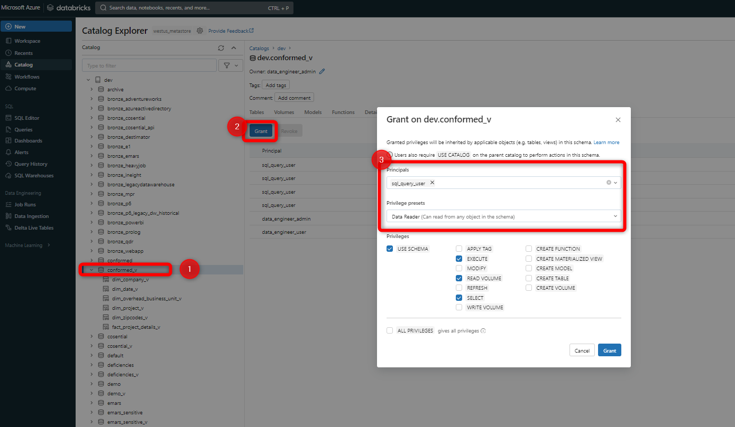

Figure 23 Image showing how groups get added to a database with the *Data Reader* preset

## Views

A view is a read-only object created from one or more tables and views in a metastore. It resides in the third layer of Unity Catalog’s [three-level namespace](https://learn.microsoft.com/en-us/azure/databricks/data-governance/unity-catalog/queries#three-level-namespace-notation). A view can be created from tables and other views in multiple schemas and catalogs. You can create [dynamic views](https://learn.microsoft.com/en-us/azure/databricks/data-governance/unity-catalog/) to enable row- and column-level permissions.

See [Create a dynamic view](https://learn.microsoft.com/en-us/azure/databricks/data-governance/unity-catalog/create-views#dynamic-view).

### Dynamic Views

In order to limit users to only view data that. Below is a diagram of the schema used to generate the dynamic views and limit data:

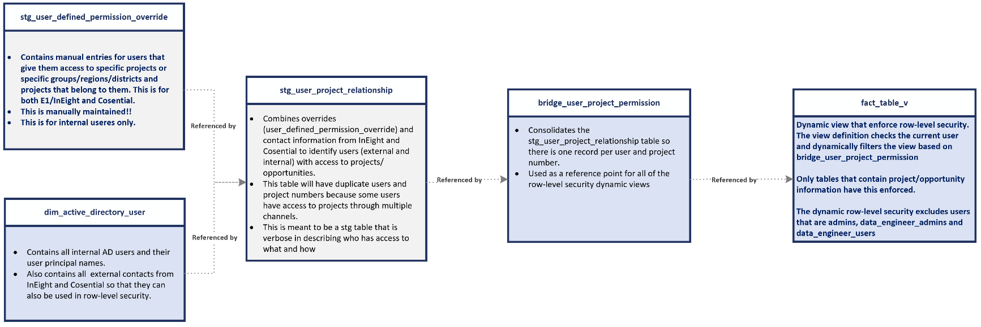

The table *bridge_user_project_permission* table is the main driver of what limits the rows in a view to a project number.

### Applying RLS to Silver Tables

By default, no users, other than data_engineers, have access to the bronze layer so no RLS is required. But users do have access to the silver layer databases and views (e.g. silver_ineight_v).

1. The RLS gets applied in the silver layer through the *bronze_to_silver* notebook located at *data_engineering/200_bronze_to_silver/bronze_to_silver.* The metadata for what column to use for identifying the project number to apply RLS is passed in through metadata. This value comes from the metadata database in the adf.dataProcess table from ProjectId column.

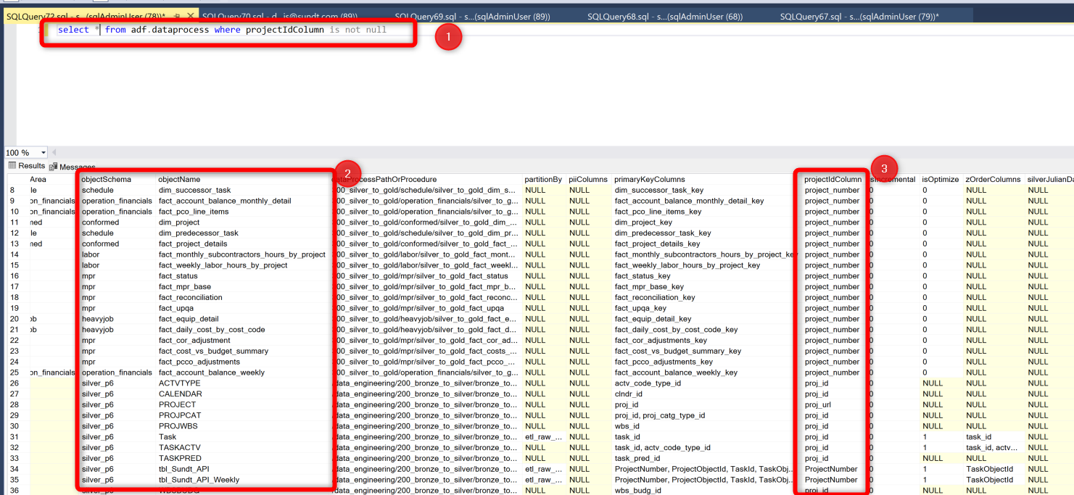

Figure 24 Figure showing the objects and their projectIdColumn

The ProjectIdCOlumn value is passed in to Databricks via Data Factory through the standard pipeline process described here.

1. The Databricks notebook applies a function called *assign_rls_by_project_number* if there is a *ProjectIDColumn* value

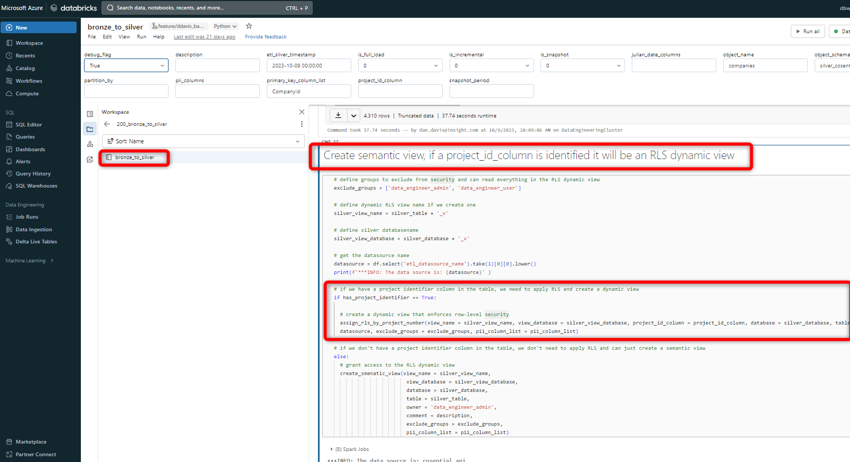

Figure 25 RLS function in the bronze_to_silver layer

If there is no *ProjectIdColumn* then a default view is created with no RLS in the view definition. This default view is simply *SELECT * FROM TABLE*

The function definition for *assign_rls_by_project_number* can be found in the common_functions notebook

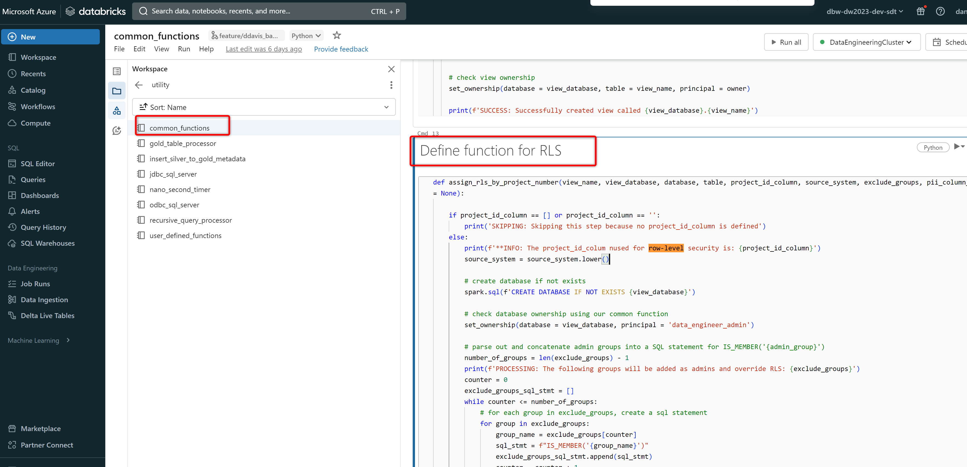

This will create the dynamic view in the view database with a view definition that enforces row-level security

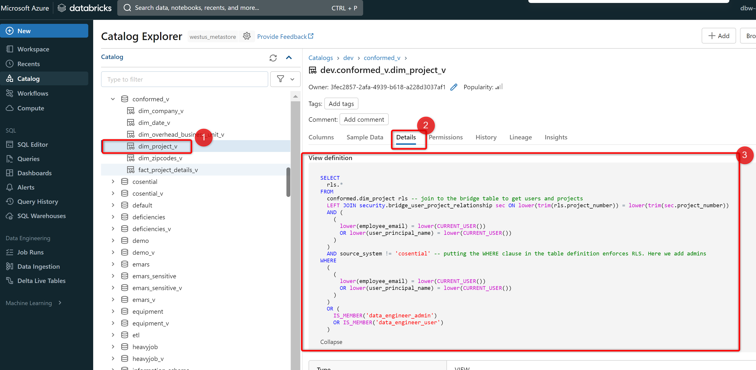

## Models

A model resides in the third layer of Unity Catalog’s three-level namespace. In this context, “model” refers to a machine learning model that is registered in the [MLflow Model Registry](https://learn.microsoft.com/en-us/azure/databricks/mlflow/models-in-uc). To create a model in Unity Catalog, users must have the CREATE MODEL privilege for the catalog or schema. The user must also have the USE CATALOG privilege on the parent catalog and USE SCHEMA on the parent schema.

## Identity management for Unity Catalog

Unity Catalog uses the identities in the Azure Databricks account to resolve users, service principals, and groups, and to enforce permissions.

To configure identities in the account, follow the instructions in [Manage users, service principals, and groups](https://learn.microsoft.com/en-us/azure/databricks/administration-guide/users-groups/). Refer to those users, service principals, and groups when you create [access-control policies](https://learn.microsoft.com/en-us/azure/databricks/data-governance/unity-catalog/manage-privileges/) in Unity Catalog.

Unity Catalog users, service principals, and groups must also be added to workspaces to access Unity Catalog data in a notebook, a Databricks SQL query, Catalog Explorer, or a REST API command. The assignment of users, service principals, and groups to workspaces is called identity federation.

All workspaces that have a Unity Catalog metastore attached to them are enabled for identity federation.

Sundt Databricks Access Connector for Authentication: *dbw-ac-dw2023-prod-sdt*

### Admin roles for Unity Catalog

The following admin roles are required for managing Unity Catalog:

* **Account admins** can manage identities, cloud resources and the creation of workspaces and Unity Catalog metastores.

Account admins can enable workspaces for Unity Catalog. They can grant both workspace and metastore admin permissions.

* **Metastore admins** can manage privileges and ownership for all securable objects within a metastore, such as who can create catalogs or query a table.

The account admin who creates the Unity Catalog metastore becomes the initial metastore admin. The metastore admin can also choose to delegate this role to another user or group. We recommend assigning the metastore admin to a group, in which case any member of the group receives the privileges of the metastore admin. See [(Recommended) Transfer ownership of your metastore to a group](https://learn.microsoft.com/en-us/azure/databricks/data-governance/unity-catalog/get-started#transfer-ownership).

* **Workspace admins** can add users to an Azure Databricks workspace, assign them the workspace admin role, and manage access to objects and functionality in the workspace, such as the ability to create clusters and change job ownership.

See [Manage users, service principals, and groups](https://learn.microsoft.com/en-us/azure/databricks/administration-guide/users-groups/).

### Data permissions in Unity Catalog

In Unity Catalog, data is secure by default. Initially, users have no access to data in a metastore. Access can be granted by either a metastore admin, the owner of an object, or the owner of the catalog or schema that contains the object. Securable objects in Unity Catalog are hierarchical and privileges are inherited downward.

You can assign and revoke permissions using Catalog Explorer, SQL commands, or REST APIs.

See [Manage privileges in Unity Catalog](https://learn.microsoft.com/en-us/azure/databricks/data-governance/unity-catalog/manage-privileges/).

## Databricks Access

You can read more about Databricks users and adding them to a workspace [here](https://learn.microsoft.com/en-us/azure/databricks/administration-guide/users-groups/users#add-user-workspace).

There are five roles defined in Databricks:

* Account admins can manage your Databricks account-level configurations, including creation of workspaces, billing, and cloud resources. Account admins can add users to the account and assign them admin roles. They can also give users access to workspaces, as long as those workspaces use identity federation.

Workspace admins can add users to an Azure Databricks workspace, assign them the workspace admin role, and manage access to objects and functionality in the workspace, such as the ability to create clusters or access specified persona-based environments.

* Metastore admins can manage privileges for all securable objects within a Unity Catalog metastore, such as who can create catalogs or query a table.
* Marketplace admins can create and manage listings in Databricks Marketplace.
* Account users can use the account console to view and connect to their workspaces. Account and workspace admins can add users to the account.
* Workspace users perform data science, data engineering, and data analysis tasks in workspaces. Account and workspace admins can give account users access to workspaces, as long as those workspaces use identity federation.

**Managing Identities:**

To manage identities in Azure Databricks, you must be either an account admin or a workspace admin. The following table details the permissions needed for user management actions:

|  |  |
| --- | --- |
| **Action** | **Who Can perform this action?** |
| Add users and service principals | Account admins can add users and service principals to the account.  Workspace admins can add users and service principals to the account from their workspaces. |
| Update users and service principals | Account admins can update users and service principals in the account. |
| Delete users and service principals | Account admins can delete users and service principals from the account. |
| Add groups | Account admins can add groups to the account.  Workspace admins can add workspace-local groups to the workspace admin’s workspaces. |
| Update groups | Account admins can update groups in the account.  Workspace admins can update workspace-local groups in the workspace admin’s workspaces. |
| Delete groups | Account admins can delete groups from the account.  Workspace admins can delete workspace-local groups from the workspace admin’s workspaces. |

**Adding Users to Databricks:**

1. Navigate to the account console

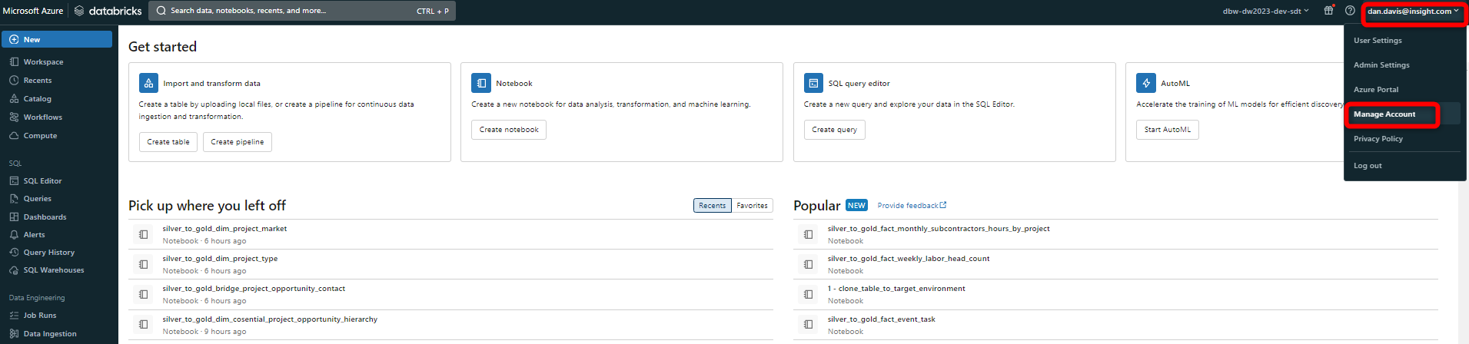

1. Add a user to Databricks

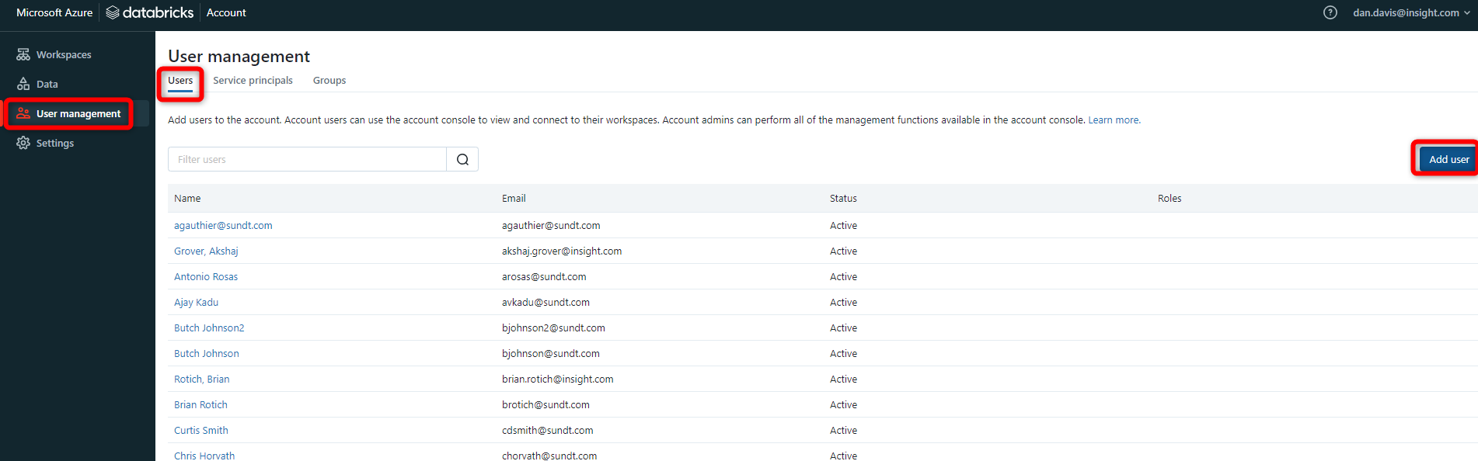

1. Add user to a specified group.

* Add users to the appropriate group below:

|  |  |
| --- | --- |
| Group | Description |
| Azure Insight Data Warehouse Contributor | Azure Active Directory security group that has been brought in and added to sql_query_users |
| Data_engineer_admin | Data engineering admins that have access to everything in Databricks and all Delta tables |
| data_engineer_user | Data engineering users that have access to the Data Engineering section in Databricks but don’t have admin access to everything |
| Metastore_admin | Users that can manage and administer the metastore |
| Parent_sql_access | The group that gets added to the sql_access entitlement in workspaces to give its child group members (e.g. sql_query_user) SQL access |
| Parent_Workspace_access | The group that gets added to the workspace access entitlement in workspaces to give its child group members workspace access |
| Parent_unrestricted_cluster_creation | The group that gets added to the unrestricted cluster creation entitlement in workspaces to give its child group members unrestricted cluster creation entitlement access |
| sql_query_emars_user | Users that have SQL access and access to see the sensitive eMars data |
| sql_query_equipment_user | Users that have SQL access and access to see the sensitive equipment data |
| Sql_query_user | Users that have SQL access to Databricks. This is the general SQL group for most Databricks users. |

As of right now, all data engineers that require access to notebooks and ***Data Science & Engineering*** workspace in Databricks are added as admins. You can create new groups with more fine-grained access control in the future for data engineers that should not be admins.

An entitlement is a property that allows a user, service principal, or group to interact with Databricks in a specified way. Entitlements are assigned to users/groups at the workspace level. In our case, the *Parent* groups are assigned entitlement.The following table lists entitlements and the workspace UI and API property name that you use to manage each one. You can use the workspace admin settings page and workspace-level SCIM REST APIs to manage entitlements.

| **Entitlement name (UI)** | **Entitlement name (API)** | **Default** | **Description** |
| --- | --- | --- | --- |
| Workspace access | workspace-access | Granted by default. | When granted to a user or service principal, they can access the Data Science & Engineering and Databricks Machine Learning persona-based environments.  Can’t be removed from workspace admins. |
| Databricks SQL access | databricks-sql-access | Granted by default. | When granted to a user or service principal, they can access Databricks SQL. |
| Allow unrestricted cluster creation | allow-cluster-create | Not granted to users or service principals by default. | When granted to a user or service principal, they can create clusters. You can restrict access to existing clusters using [cluster-level permissions](https://docs.databricks.com/en/security/auth-authz/access-control/cluster-acl.html).  Can’t be removed from workspace admins. |

# Serving and Consumption

## Infrastructure

Thedata platform uses a number of different pieces of infrastructure for serving and consumption of the data for users:

* **Orchestration:** ADF used to orchestrate and execute Power BI datasets.
* **Azure SQL Database:** Used to store metadata in ***adf.azureResources*** and ***adf. adf.powerBiDatasets*** for orchestration around Power BI dataset refreshes.
* **Compute:** Databricks [SQL Endpoint (renamed to SQL Warehouse)](https://learn.microsoft.com/en-us/azure/databricks/sql/admin/create-sql-warehouse) clusters are used as the compute engine for querying data by users and Power BI.
* **Storage:** Azure data lake (storage account with hierarchical namespace enabled) is used to store tables used by the SQL Endpoint for querying. Power BI Premium capacity and import mode is used to store data imported into datasets.

There is no data movement between the Gold layer and the serving layer. The serving layer is simply a SQL Endpoint, or a cluster, that is used as the SQL interface and compute for when users and Power BI query dimension and fact tables in the SQL workspace view in Databricks. Data Factory executes pipelines for triggering datasets refreshes in Power BI using triggers and using the ***plGoldToPbi*** pipelines in ADF. These pipelines are dynamically populated with metadata that define what datasets to execute and what secrets to use for authenticating to the Power BI datasets.. This metadata information is stored in the metadata database in the ***adf.powerBiDatasets*** table.

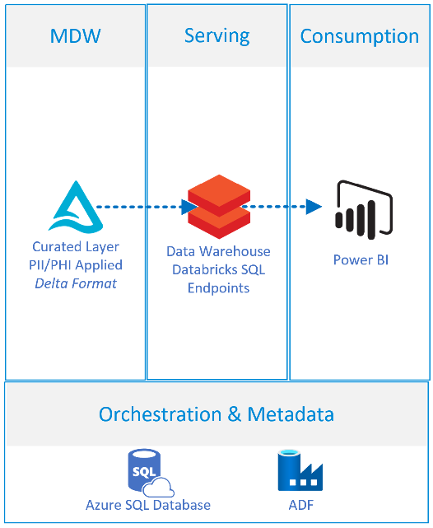

Figure 27 Example showing the resources and components that make up the serving and consumption layers.

## Orchestration and Metadata

### Databricks SQL Warehouse

There is no need for orchestration or metadata for the [SQL Warehouse](https://learn.microsoft.com/en-us/azure/databricks/sql/admin/create-sql-warehouse), it automatically reflects the current state of tables in the Gold layer.

### Power BI

Metadata for refreshing Power BI datasets is stored in the table ***adf.powerBiDatasets.*** This table contains the workspace and dataset ID’s required for refreshing Power BI datasets.



Figure 28 Metadata entries used for refreshing Power BI datasets

The figure above shows the metadata entries used for refreshing a Power BI dataset in the ***adf.powerBiDatasets*** table.

In ADF, the pipeline ***plGoldtoPbiParent*** gets a list of all datasets from the metadata. For each dataset retrieves, it will execute the child pipeline ***plGoldtoPbiChild****,* which handlesauthenticating to the Power BI dataset, creating the [Power BI refresh api](https://learn.microsoft.com/en-us/power-bi/connect-data/asynchronous-refresh), and then calling the dataset refresh. The ***plGoldtoPbiChild*** pipeline will then check the status of the dataset every 15 minutes to see if it failed or if it succeeded.

**Note:** Authentication to the Power BI datasets are handled through service principals that are listed as admins on the workspace the dataset belongs to. If you add new datasets that belong to new workspaces, you must add the Active Directory Security group called ***PowerBi-ServicePrincipals*** as an ***admin*** on the new workspace in Power BI. If you do not add this security group as an admin on the workspace, authentication will fail.

Currently, the only Power BI datasets that are refreshed are ones with the *SWA* prefix that have row-level security enabled. On top of that, only 3 tables are refreshed (tables required for RLS). The tables refreshed are:

* Dim_active_directory_user_v
* Bridge_user_project_relationship_v

These tables are indicated as the only ones to be refreshed in the ADF pipeline via the body of the POST request that initiates the refresh:

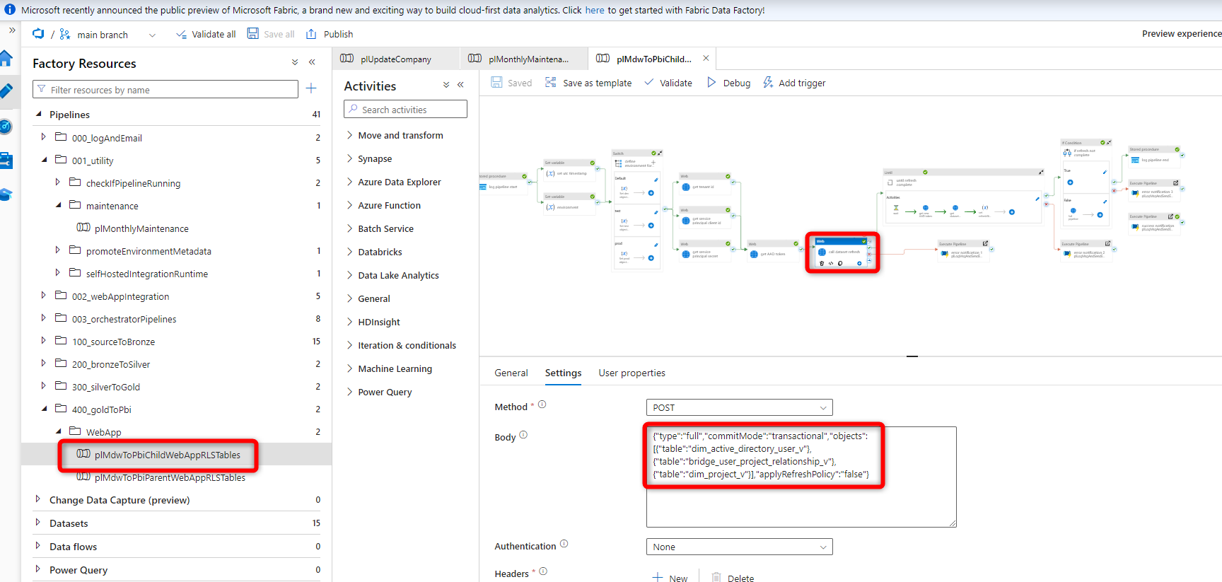

## Monitoring

To monitor a SQL warehouse, click the name of a SQL warehouse and then the Monitoring tab. On the Monitoring tab, you see the following monitoring elements:

* Live statistics: Live statistics show the currently running and queued queries, active SQL sessions, the warehouse status, and the current cluster count.
* Time scale filter: The monitoring time scale filter sets the time range for the query count chart, running cluster chart, and the query history and event log table. The default time range is 8 hours, but you can specify 24 hours, 7 days, or 14 days. You can also click and drag on the bar chart to change the time range.
* Query count chart: The query count ch e number of queries running or queued on the warehouse during the selected time frame.
* Running clusters chart: The running clusters chart shows the number of clusters allocated to the warehouse during the selected time frame. During a cluster recycle, this count may temporarily exceed configur art shows thed maximum.
* Query history table: The query history table shows all of the queries active during the selected time frame, their start time and duration, and the user that executed the query. You can filter the queries by user, query duration, query status, and query type.

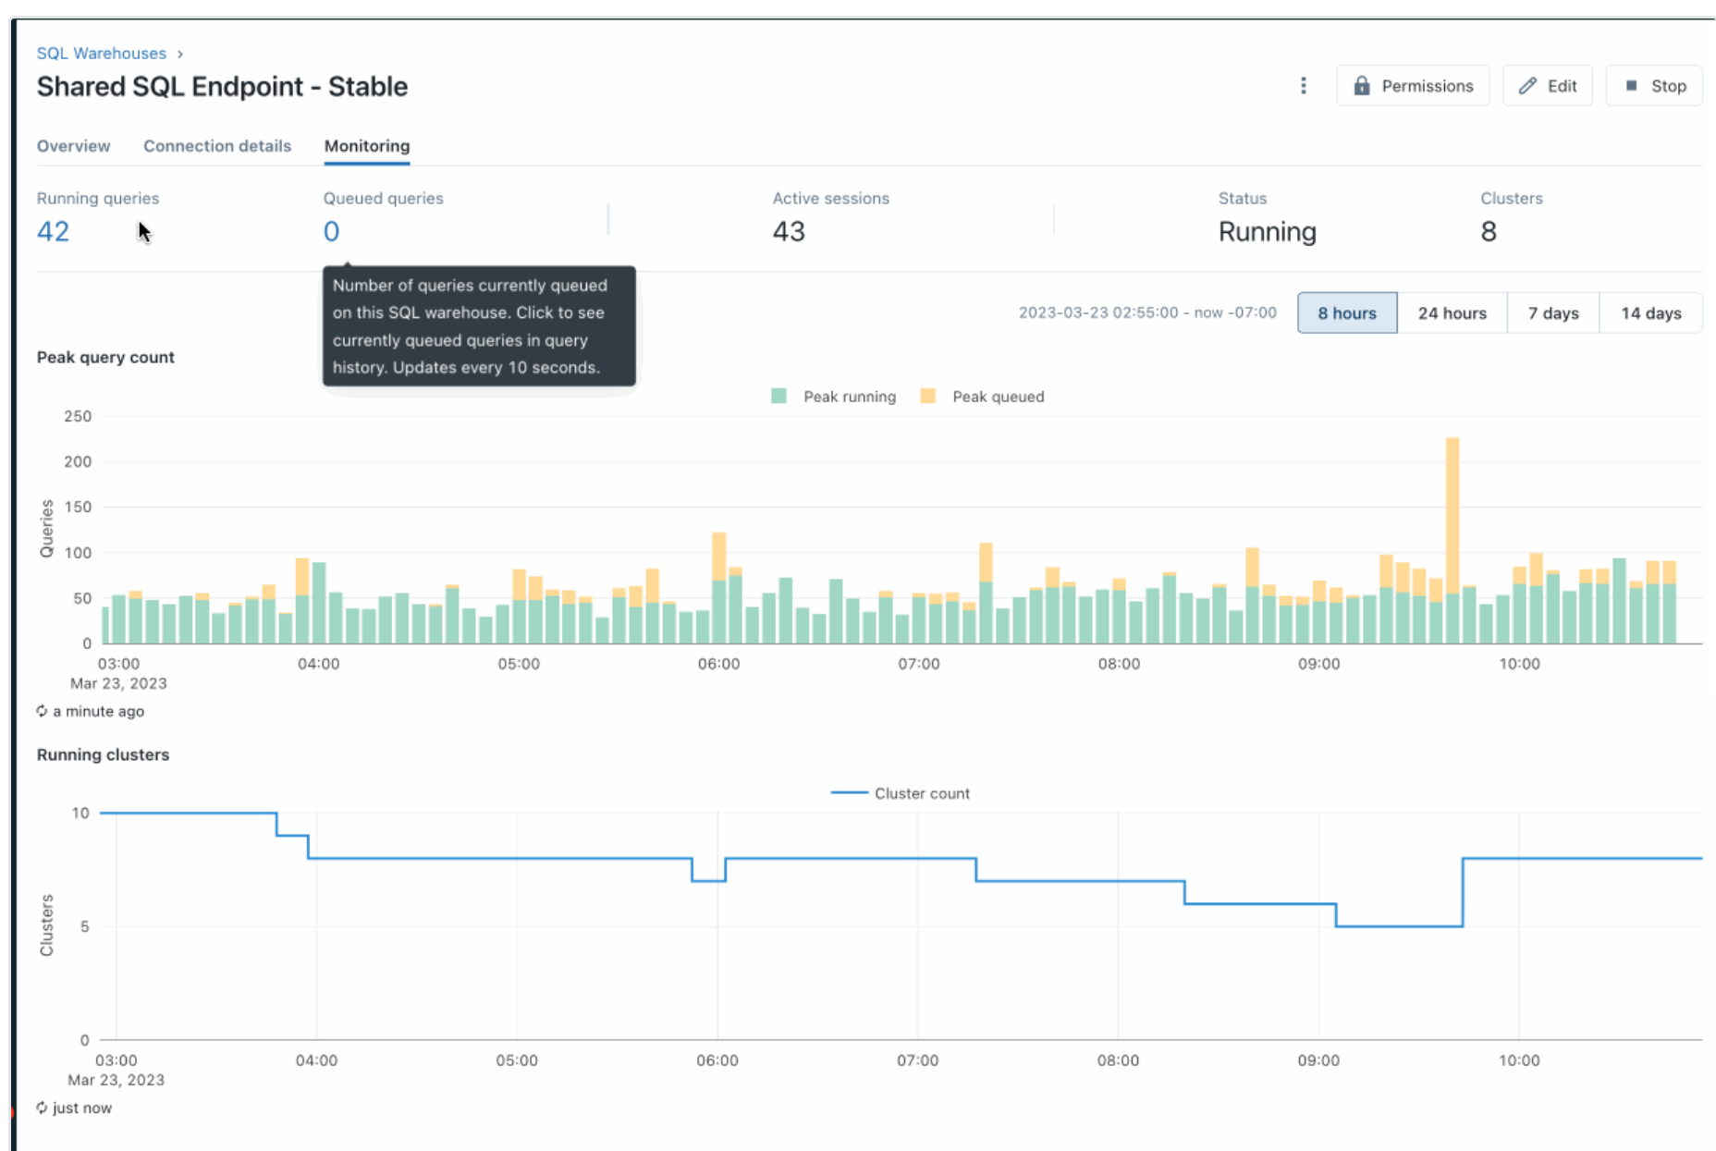

## Tuning and Performance

To configure the cluster of the Databricks SQL Warehousethat users use to query and that Power BI uses to query data:

1. Navigate to the SQL workspace and
2. Go to SQL Warehouses
3. Click **Edit**

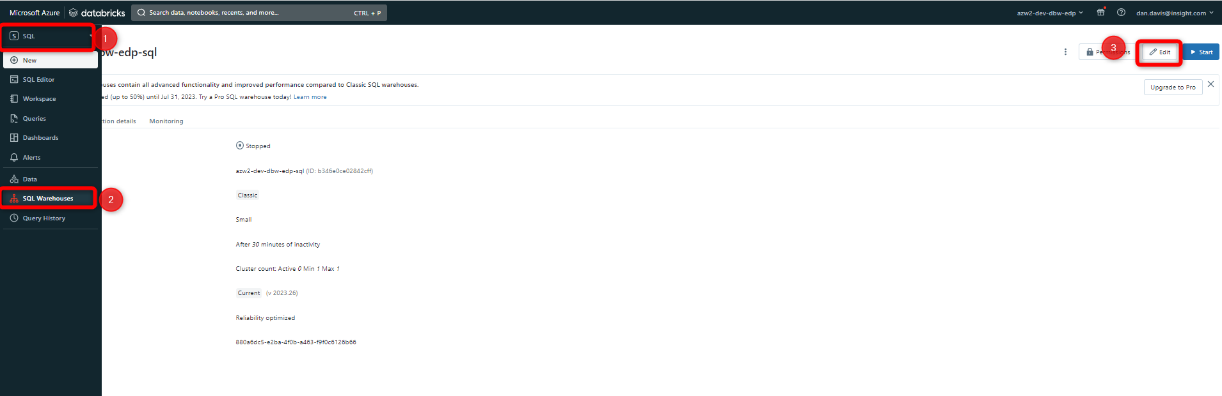

Figure 29 Navigating to the SQL Endpoint/Warehouse configuration

Once you are on the edit screen, you can change the size, configuration and scaling of the cluster to better accommodate workloads. To reduce query latency, increase the size of the cluster or the scaling.

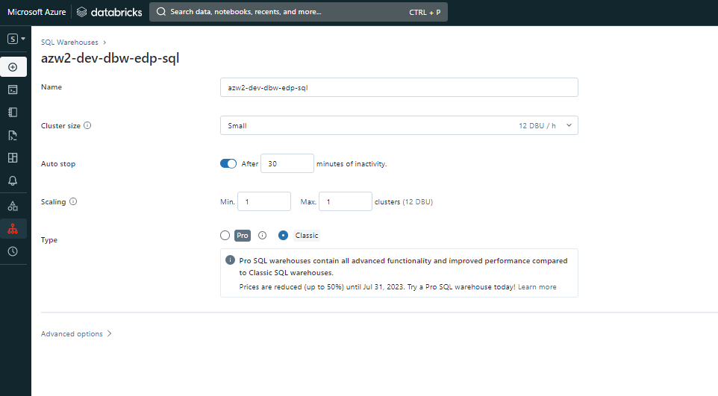

Figure 30 SQL Endpoint or SQL Warehouse cluster configuration screen

# Source Control and Environment Promotion

## General Branching Strategy

Version control systems are software that help you track changes you make in your code over time. As you edit your code, you tell the version control system to take a snapshot of your files. The version control system saves that snapshot permanently so you can recall it later if you need it. Use version control to save your work and coordinate code changes across your team.

* The Data Platform uses [Azure Devops Repos](https://learn.microsoft.com/en-us/azure/devops/repos/get-started/what-is-repos?view=azure-devops) for source control.
  + Databricks Repository Name: [Databricks](https://dev.azure.com/sundt/DataWarehouse2023/_git/DW2023-Databricks)
  + Data Factory Repository Name: [DataFactory](https://dev.azure.com/sundt/DataWarehouse2023/_git/DW2023-DataFactory)

Currently, the development team uses a [Gitflow](https://www.atlassian.com/git/tutorials/comparing-workflows/gitflow-workflow) workflow approach for development. Under this model, developers create a feature branch and delay merging it to the main trunk branch until the feature is complete. Instead of a single main branch, this workflow uses two branches to record the history of the project. The main branch stores the official release history, and the develop branch serves as an integration branch for features.

This approach is used primarily because it leads to fewer changesets introduced to the shared branch (main), which allows for easier identification of the changes that have been made and who made them. This approach also better supports a team that is less familiarity with source code control process and provides opportunities for review and mentoring will be considered necessary by those in charge.

#### Branches

**Main and Develop Branch**

The main branch stores the official release history, and the develop branch serves as an integration branch for features.

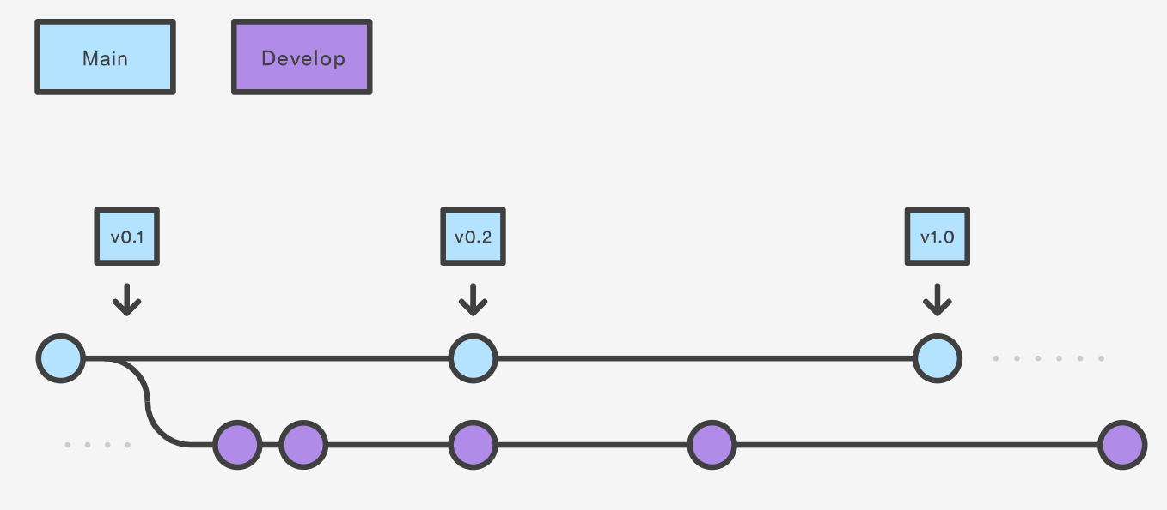

**Feature Branches**

Each new feature should reside in its own branch, which can be pushed to the central repository for backup/collaboration. But, instead of branching off of main, feature branches use develop as their parent branch. When a feature is complete, it gets merged back into develop. Features should never interact directly with main

Feature branches are generally created off to the latest develop branch. When you’re done with the development work on the feature, the next step is to merge the ***feature_branch*** into ***develop***.

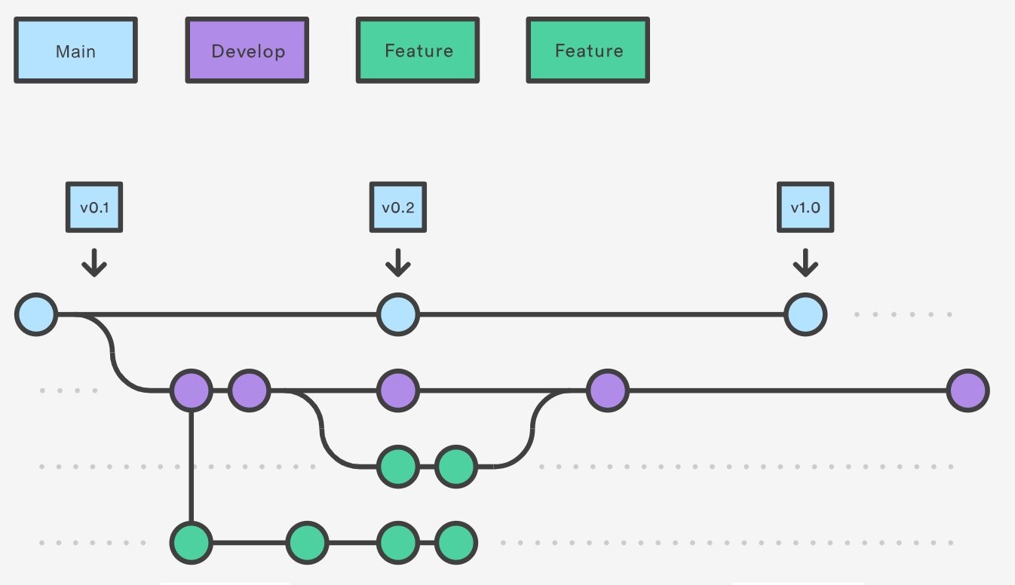

#### Branch Naming Convention

**Feature branches :**

* Naming Convention: feature/<developer first initial><developer last name>_<description of feature>
* Example: feature/ddavis_ cosentialenhancement

**Bug branches:**

* Naming Convention: bug/<developer first initial><developer last name>_<description of bug fix>
* Example: feature/ddavis_cosentialenhancement

## Azure DataFactory

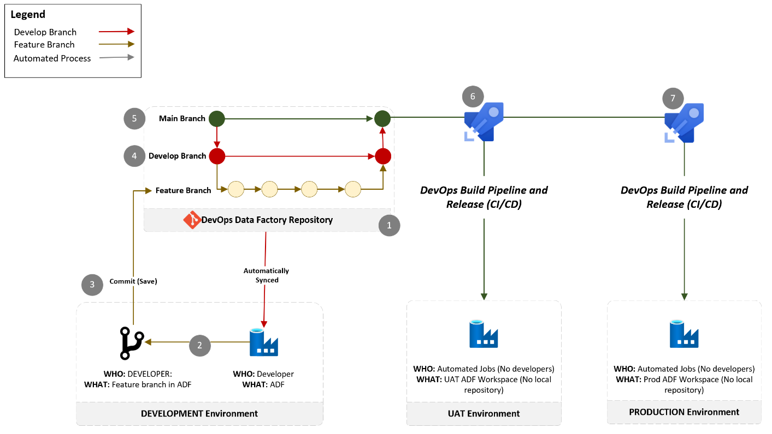

The numbered steps in the figure above show:

1. Data Factory (ADF) source code stored in remote repository called Databricks hosted in Azure DevOps. In ADF, changes with the remote repository are automatically synced with the Data Factory environment, so there is no need to pull changes or create a local repository.
2. Developer creates a feature branch and does their development work (e.g. create pipelines, make changes, etc.)
3. Developer commits (saves) changes in ADF that automatically get synced with the repository called Data Factory hosted in Azure DevOps
4. Developer submits pull request that gets merged with the integration branch called ***develop***
5. Once you are ready to integrate changes with the main branch, develop submits pull request that gets merges the develop branch into the ***main branch.***
6. Develop branch gets deployed to **Test** environment via DevOps build pipelines and release. This is called continuous integration and continuous development (CI/CD).
7. Develop branch gets deployed to **PROD** environment via DevOps build pipelines and release. This is called continuous integration and continuous development (CI/CD).

### Source Control

Azure Data Factory source code is stored in remote repository called [DataFactory hosted in Azure DevOps.](https://dev.azure.com/sundt/DataWarehouse2023/_git/DW2023-DataFactory)

You can read more about how Data Factory was connected to Azure DevOps for source control [here](https://learn.microsoft.com/en-us/azure/data-factory/source-control).

The Data Factory YAML scripts for the build pipelines are in the repository under the *.azuredevops* folder.

### ADF Publish

When data factory is connected to a DevOps repository, it is said to operate in GIT mode and only runs triggers and artifacts that have been published. In this mode, the publish option will work from branch designated as "Collaboration branch" which is the ***main*** branch. **This only applies to the development environment.** In order to ***Publish*** in the development environment, users must load the Data Factory UI and select ***Publish*** to deploy changes and ensure that triggers run the newly generated pipelines and artifacts. **You do not need to publish in Test or PROD, this automatically happens during the environment promotion.**

Below are the steps to publish:

1. To publish in the development environment, load the Data Factory UI and select ***Publish.***

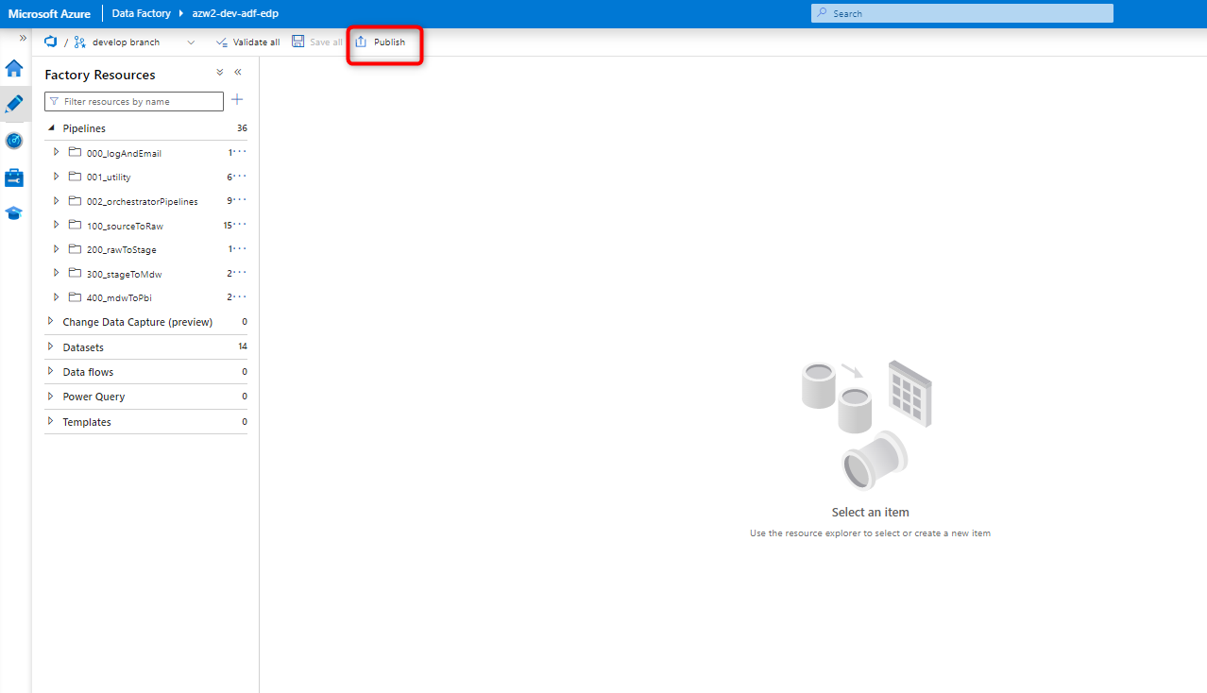

1. Once you click publish, then if there are no issues then you will be prompted to confirm the list of changes since the last time you published. Click ***OK*** to complete the publish process.

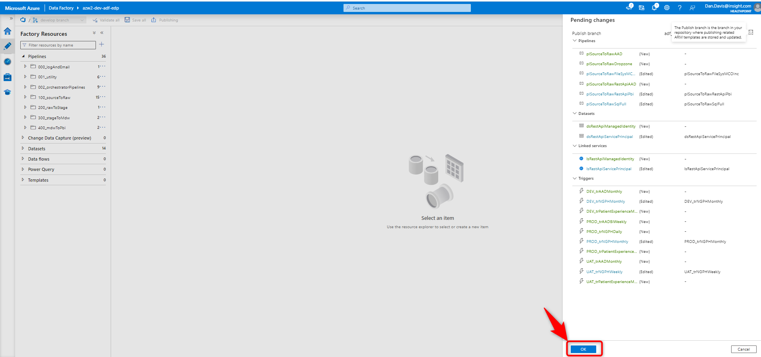

1. If you received an error during the publishing process, then you must resolve the error using a feature branch and complete the PR process to resolve and then attempt the publish process (steps 1 and 2) again.

### Environment Promotion

The steps below walk you through how to promote Data Factory code to a higher environment.

* ***Main Branch:*** When you complete a PR to the ***main*** branch, then a build and a release are automatically created, thus you can skip steps 1 thru 4.
* ***Develop Branch:*** When you complete a PR to the develop branch and wish to promote that branch to a higher environment, then you need to complete all steps below:

Steps to promote to higher environment:

1. Ensure that you have ***Published*** all recent changes in the development environment to ensure there will be no errors when deploying to a higher environment.
2. Run the build pipeline by navigating to Azure DevOps and going to ***Pipelines*** and select ***Datafactory***

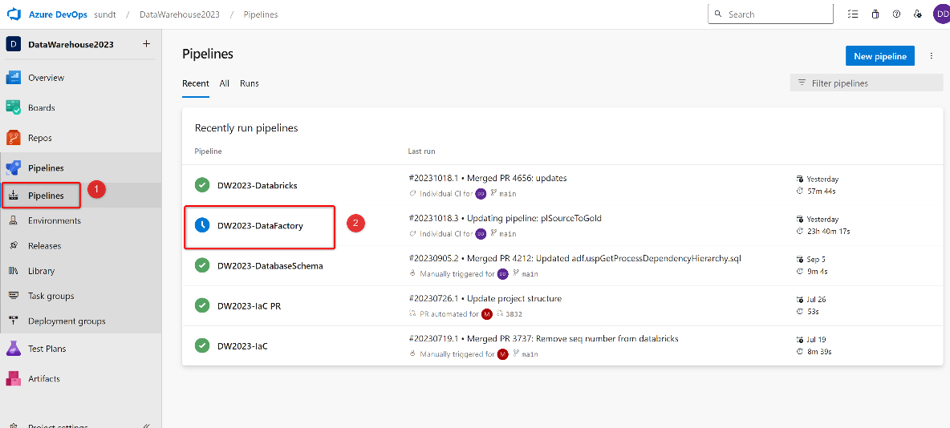

1. Click ***Run Pipeline***

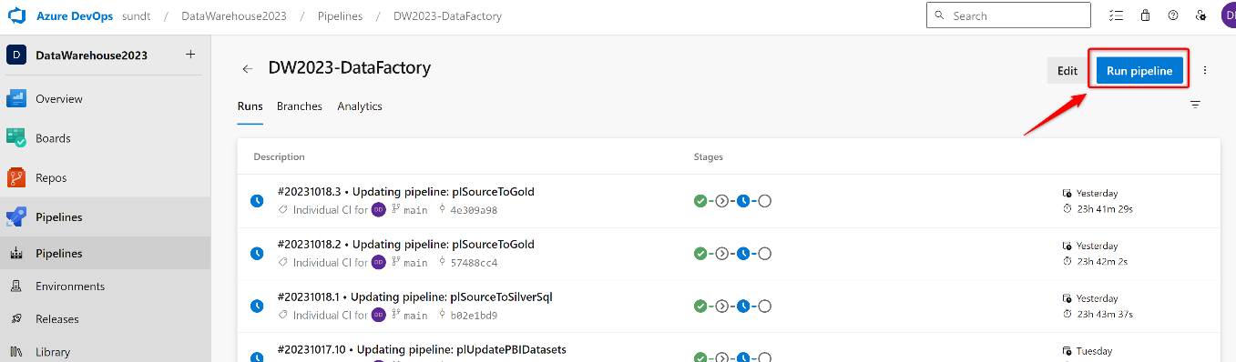

1. Select the branch you wish to create a build of and promote to the next environment (this should always be main) and then click ***Run.***

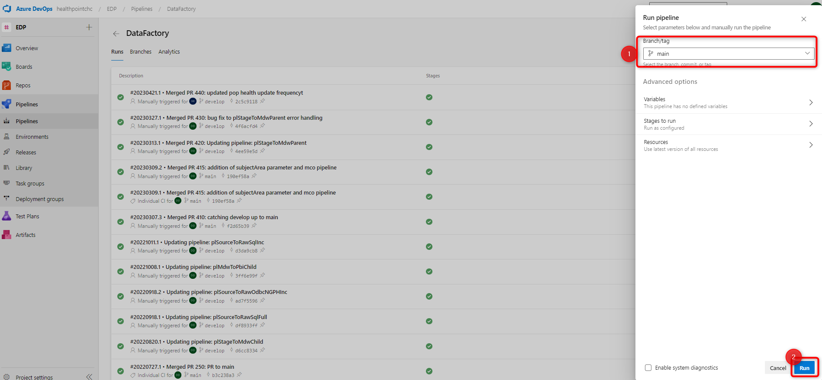

1. Next you will be brought to a screen to see the status of your build pipeline. Data Factory does not deploy to the development environment, so that stage will be skipped. In order to deploy to Test and Prod, a review and approval is required. Currently, either Dan or Jennyfer needs to approve before it can be promoted to the next stage.

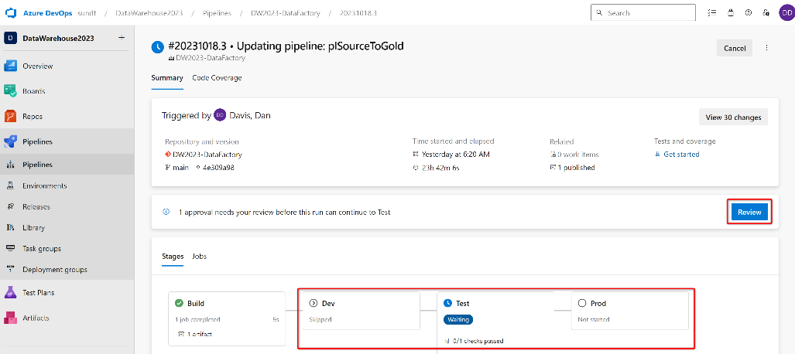

* To change the approvers, go to ***Environments*** and then click on the appropriate resource environment and add approvers.

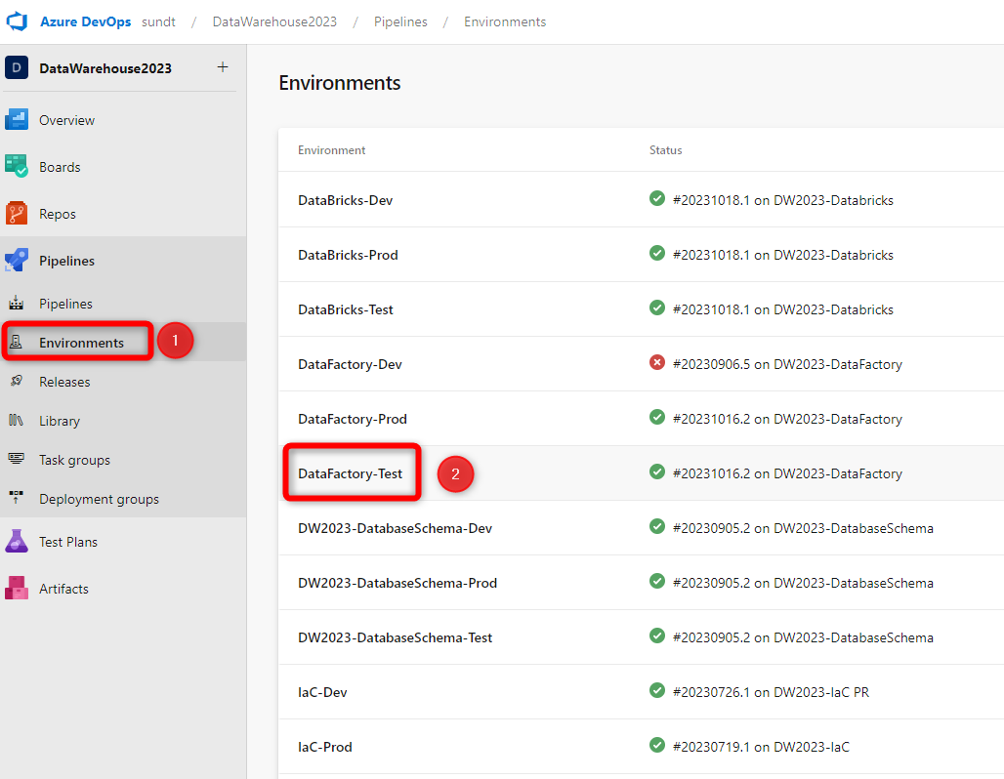

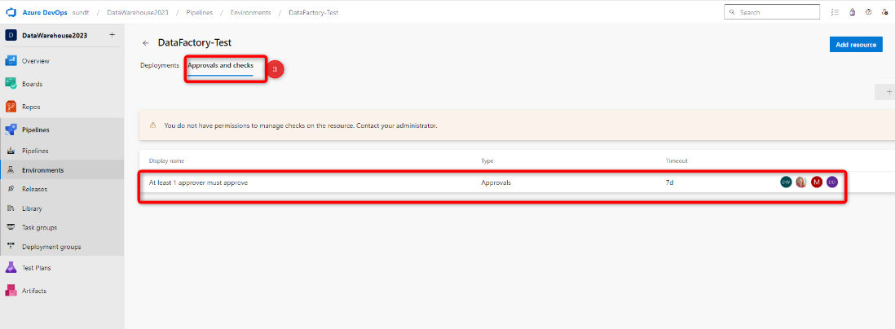

1. Once you have approved a stage, it will begin to run where you can watch the jobs status before approving the next stage.

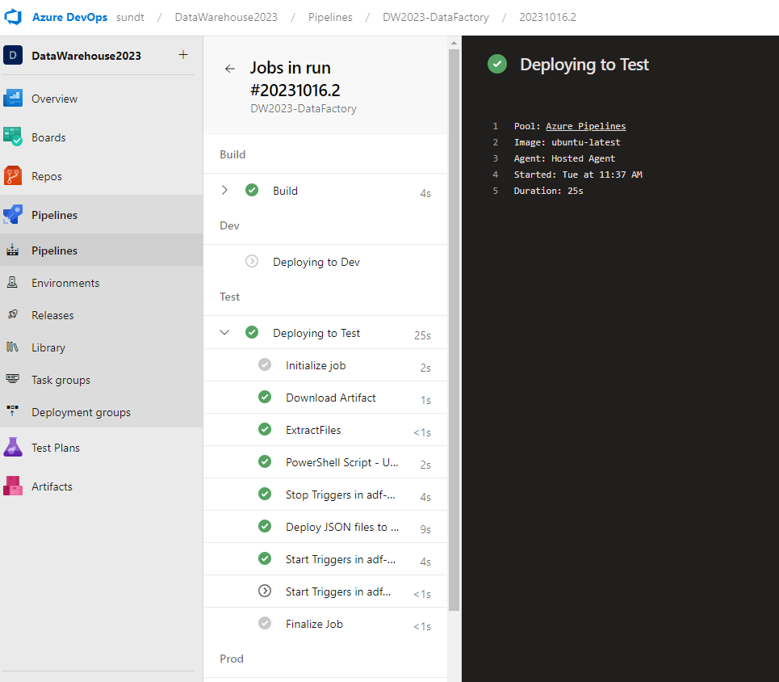

**Note:** Sometimes DataFactory deployments fail because it fails to deploy dependencies in the correct order. The error will say “invalid reference”. This is actually somewhat common when adding new pipelines that refer to other pipelines. The best solution is to run the job again, because typically the dependency will have been deployed in the previous job and then it will deploy successfully.

1. Once the deployment has run, you can go to the target environment to ensure everything was deployed, then approve the job for the next stage, or target environment (e.g. Prod).

## Databricks

### Source Control

Databricks source code stored in remote repository called [Databricks hosted in Azure DevOps](https://dev.azure.com/sundt/DataWarehouse2023/_git/DW2023-Databricks).

You can read more about how Databricks was connected to Azure DevOps for source control [here](https://learn.microsoft.com/en-us/azure/databricks/repos/get-access-tokens-from-git-provider).

The Data Factory YAML scripts for the build pipelines are in the repository under the *.azuredevops* folder.

### Environment Promotion

The figure below shows a summary of the source control and development flow along with environment promotion flow:

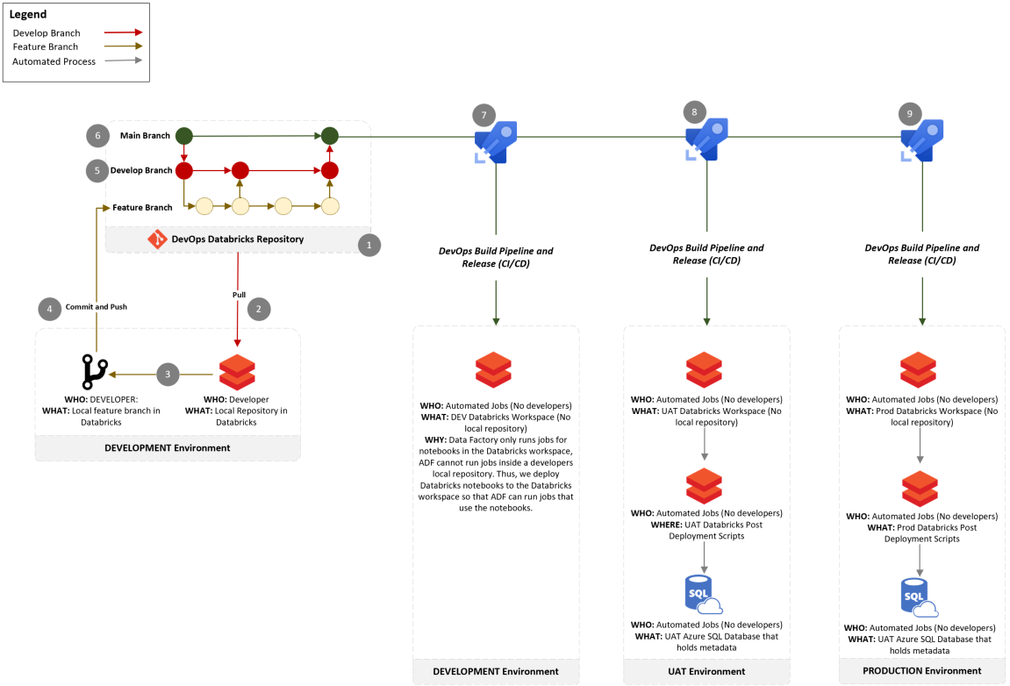

The numbered steps in the figure above show:

1. Databricks source code stored in remote repository called Databricks hosted in Azure DevOps
2. Pull new changes from the remote develop branch into the develop local Databricks repository
3. Developer creates a feature branch, based on the develop branch, and does their development work (e.g. create notebook, make changes, etc.)
4. Developer commits changes to remote repository called Databricks hosted in Azure DevOps
5. Developer submits pull request that gets merged with the integration branch called ***develop***
6. Once you are ready to integrate changes with the main branch, develop submits pull request that merges the ***develop branch*** into the ***main branch.***
7. Main branch gets deployed to **DEV** environment via DevOps build pipelines and release. This is called continuous integration and continuous development (CI/CD).
   * Data Factory only runs jobs for notebooks in the Databricks workspace, ADF cannot run jobs inside a developers local repository. Thus, we deploy Databricks notebooks to the Databricks workspace so that ADF can run jobs that use the notebooks.
8. Main branch gets deployed to **Test** environment via DevOps build pipelines and release. This is called continuous integration and continuous development (CI/CD).
   * Databricks post deployment scripts run that promote metadata from the development environment into the **Test** **Azure SQL database** that holds metadata
   * Other defined post-deployment scripts run
9. Main branch gets deployed to **PROD** environment via DevOps build pipelines and release. This is called continuous integration and continuous development (CI/CD).
   * Databricks post deployment scripts run that promote metadata from the development environment into the **PROD** **Azure SQL database** that holds metadata
   * Other defined post-deployment scripts run

#### How to Promote to a Higher Environment

The steps below walk you through how to promote Databricks code to a higher environment.

* ***Main Branch:*** When you complete a PR to the ***main*** branch, then a build and a release is automatically created, thus you can skip steps 1 thru 3.
* ***Develop Branch:*** When you complete a PR to the develop branch and wish to promote that branch to a higher environment, then you need to complete all steps below:

Steps to promote to higher environment:

1. Run the build pipeline by navigating to Azure DevOps and going to ***Pipelines*** and select ***Databricks***



1. Click ***Run Pipeline***



1. Select the branch you wish to create a build of and promote to the next environment (this should always be main) and then click ***Run.***



1. Next you will be brought to a screen to see the status of your build pipeline. Databricks deploys notebooks to development and that ***does not require approval.*** But Test and production do. In order to deploy to Test and Prod, a review and approval is required. Currently, either Dan or Jennyfer needs to approve before it can be promoted to the next stage.



* To change the approvers, go to ***Environments*** and then click on the appropriate resource environment and add approvers.





1. Once you have approved a stage, it will begin to run where you can watch the jobs status before approving the next stage.



1. These changes will only deploy notebooks to a new environment, but it will not execute the code (e.g. building a new table). If you wish to refresh the target environment, it is best to run the appropriate ADF pipeline (e.g. plSilverToGoldParent pipeline, a plSourceToBronze pipeline to load new tables from source and then plBronzeToSilver) to ensure all of the changes propagate.

## Azure SQL Database (Metadata Database)

### Source Control

Metadata database source code stored in remote repository called [Databricks hosted in Azure DevOps](https://dev.azure.com/sundt/DataWarehouse2023/_git/DW2023-Databricks). Code changes, or schema changes, should be made in SSMS using [RedGate](https://www.red-gate.com/). The repository reflects how RedGate stores the database schema, and thus all development should be done via Red Gate.

### Environment Promotion

#### How to Promote to a Higher Environment

The steps below walk you through how to promote Databricks code to a higher environment.

* ***Main Branch:*** When you complete a PR to the ***main*** branch, then a build and a release is automatically created, thus you can skip steps 1 thru 3.
* ***Develop Branch:*** When you complete a PR to the develop branch and wish to promote that branch to a higher environment, then you need to complete all steps below:

Steps to promote to higher environment:

1. Run the build pipeline by navigating to Azure DevOps and going to ***Pipelines*** and select ***DatabaseSchema***



1. Click ***Run Pipeline***



1. Select the branch you wish to create a build of and promote to the next environment (this should always be main) and then click ***Run.***



1. Next you will be brought to a screen to see the status of your build pipeline. Databricks deploys notebooks to development and that ***does not require approval.*** But Test and production do. In order to deploy to Test and Prod, a review and approval is required. Currently, either Dan or Jennyfer needs to approve before it can be promoted to the next stage.



* To change the approvers, go to ***Environments*** and then click on the appropriate resource environment and add approvers.





1. Once you have approved a stage, it will begin to run where you can watch the jobs status before approving the next stage.

